­Selenium Basics

Selenium Basics part 1

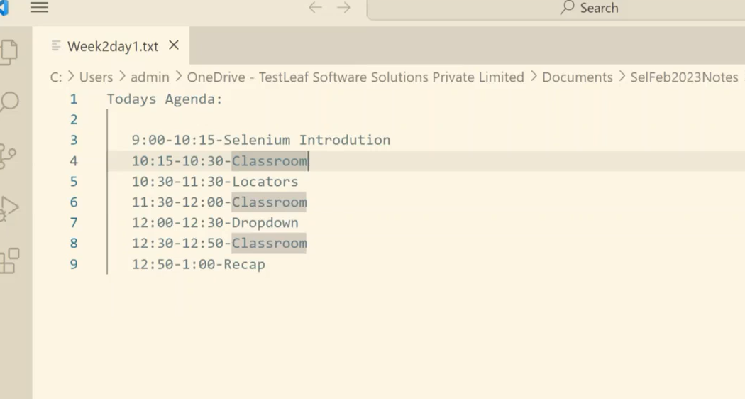­

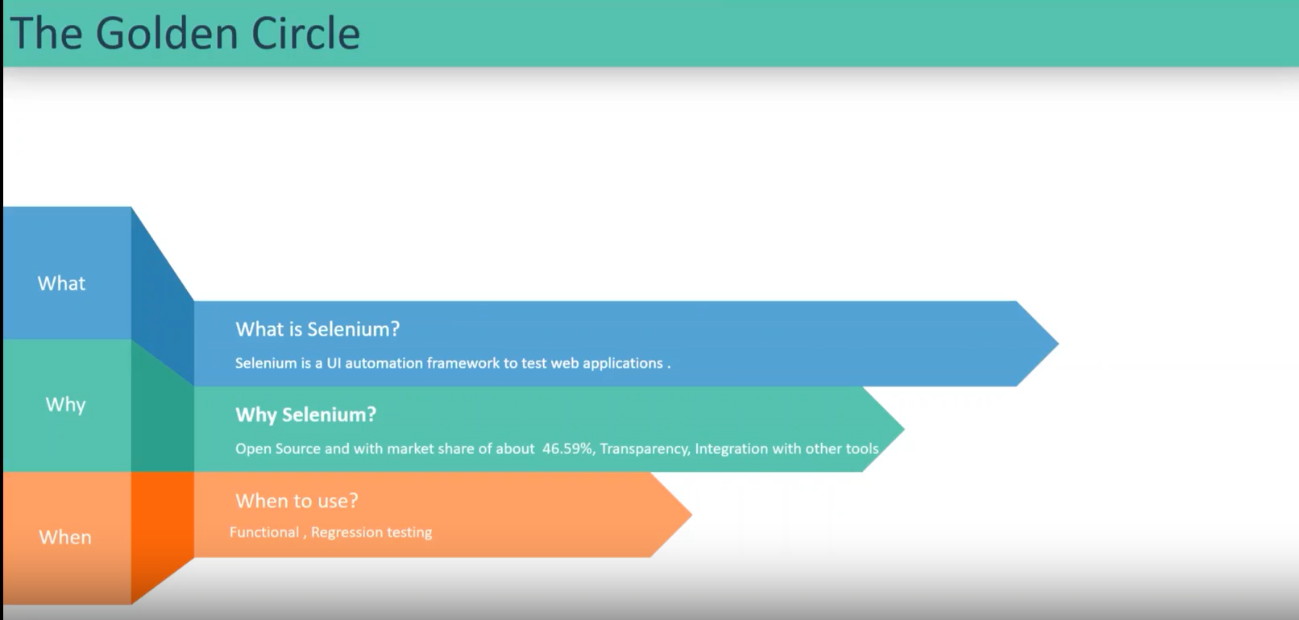

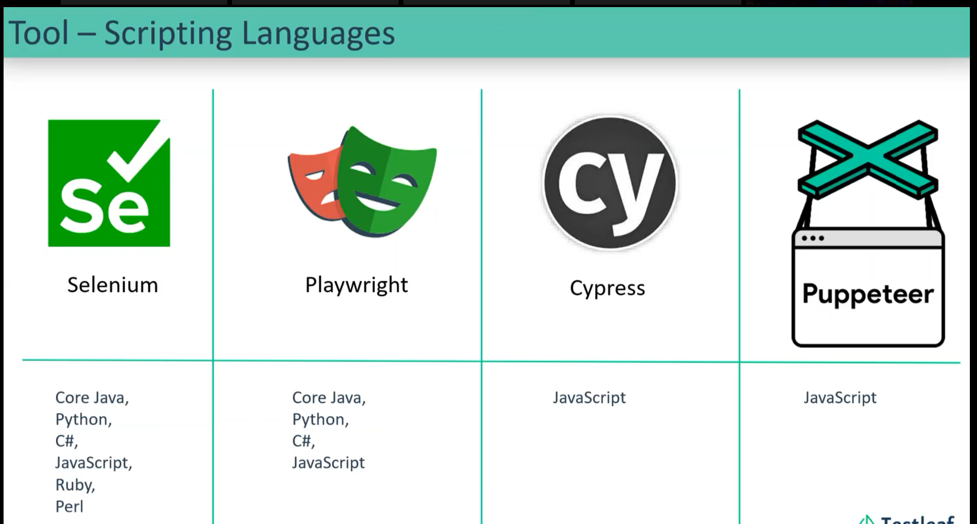

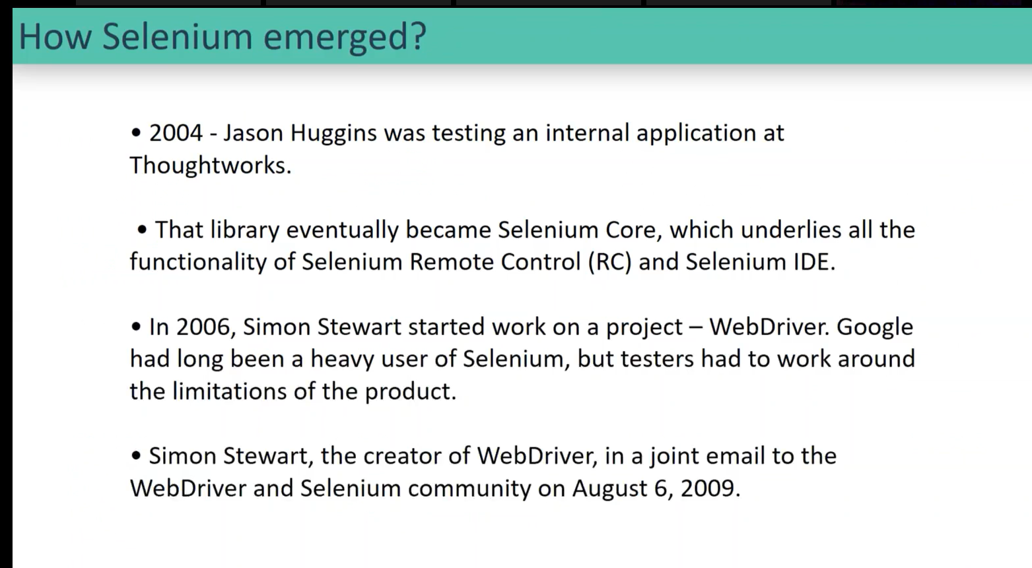

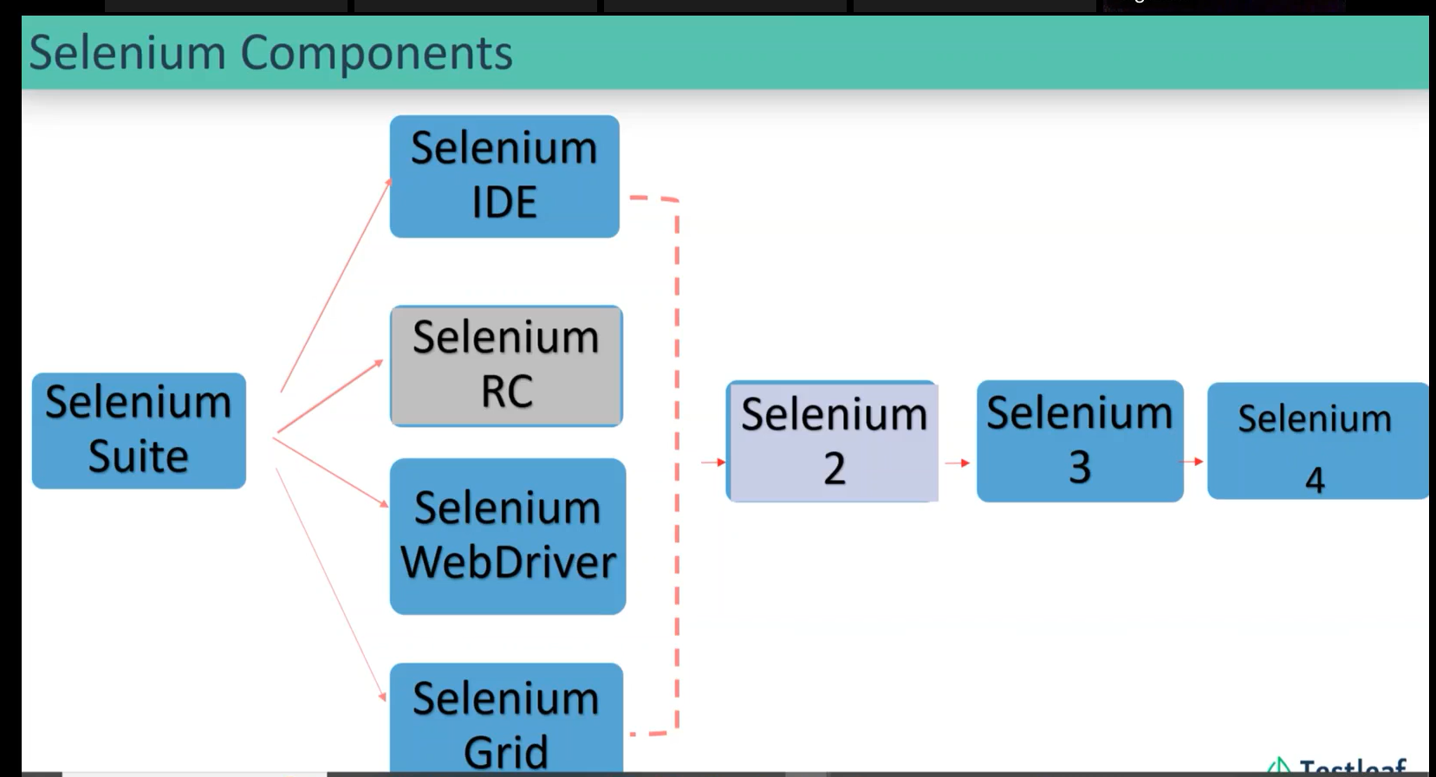

Grid in last week of the course.

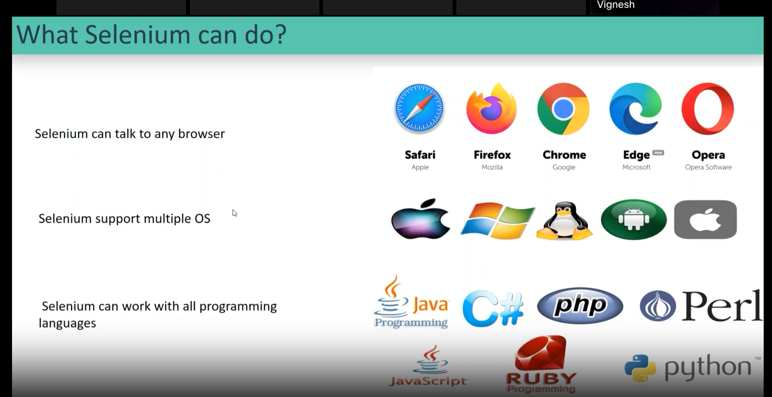

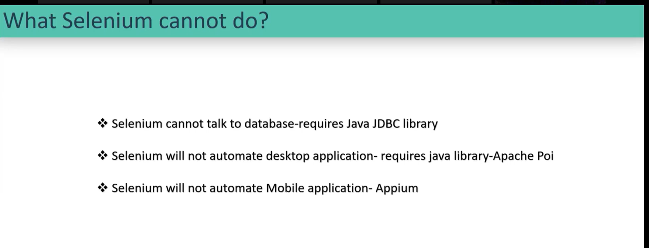

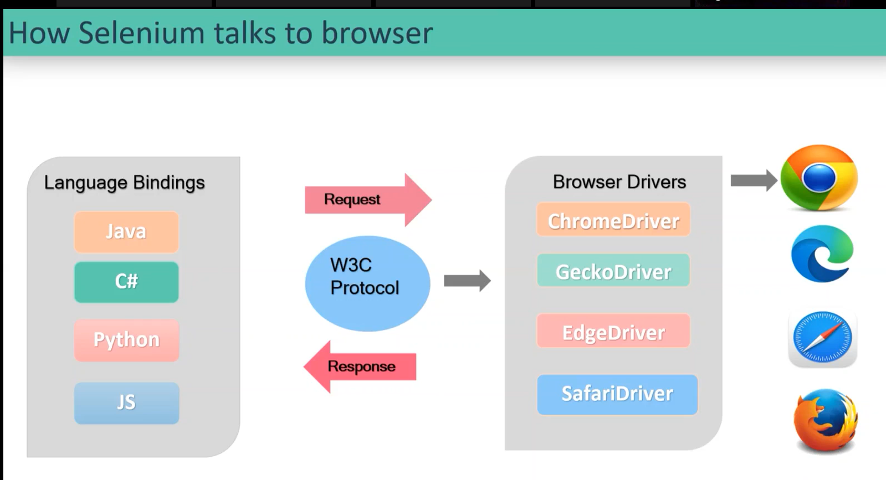

First level:

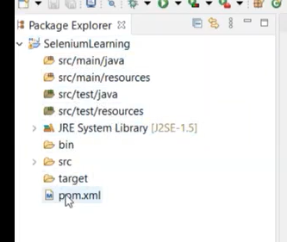

Directing to POM.xml

POM.xml: Projects Object Model 🡪 All the project related information’s will be available in the POM.xml.

Google 🡪 Maven Repository 🡪 click the first link in the maven repository.

Library called Selenium Java

Application launch:

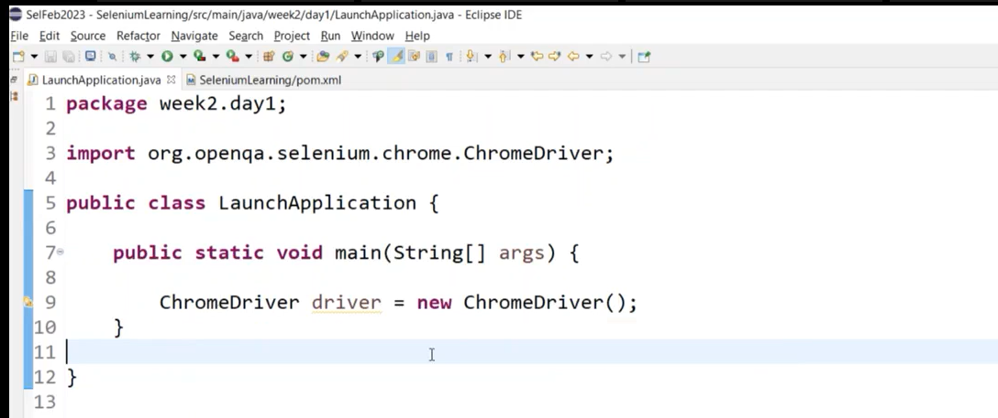

In selenium Java 4.6.0 version:

selenium manager:

* it downloads the driver in the local system.
* Setup the path.

Run -> enter .cache 🡪

In 4.6.0 only selenium manager before to that we used WebDriverManager was in usage.

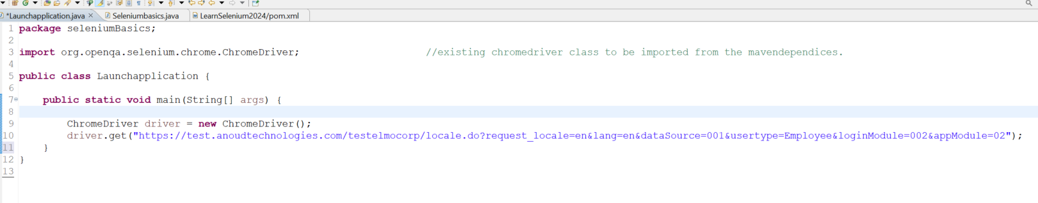

how selenium internally works??

*

* Selenium internals: going to write an automation script is going to written in JAVA language. this script interacts with the browser.

* How to interact with the web elements in a web application

* DOM: these information’s are available at the HTML Document model (DOM-Document Object Model) f12/ inspect.

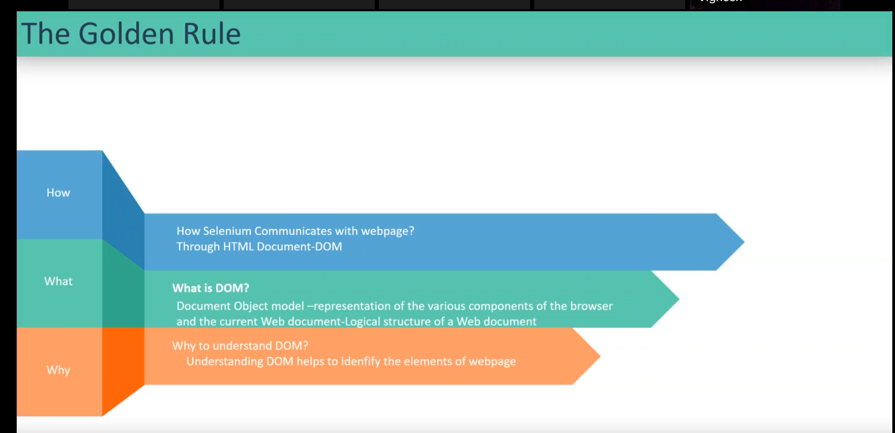

Interaction with the web elements

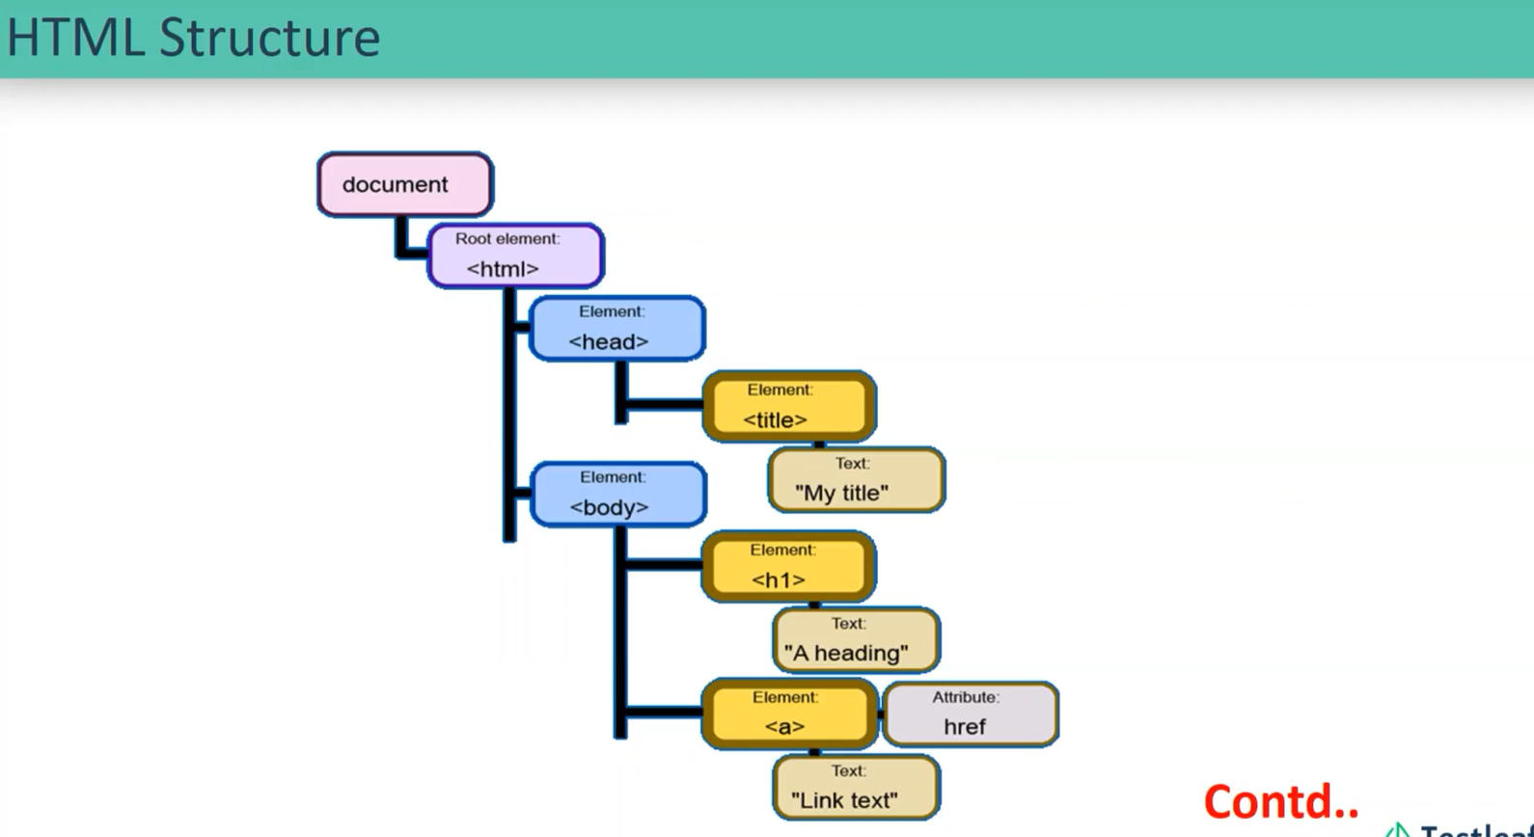

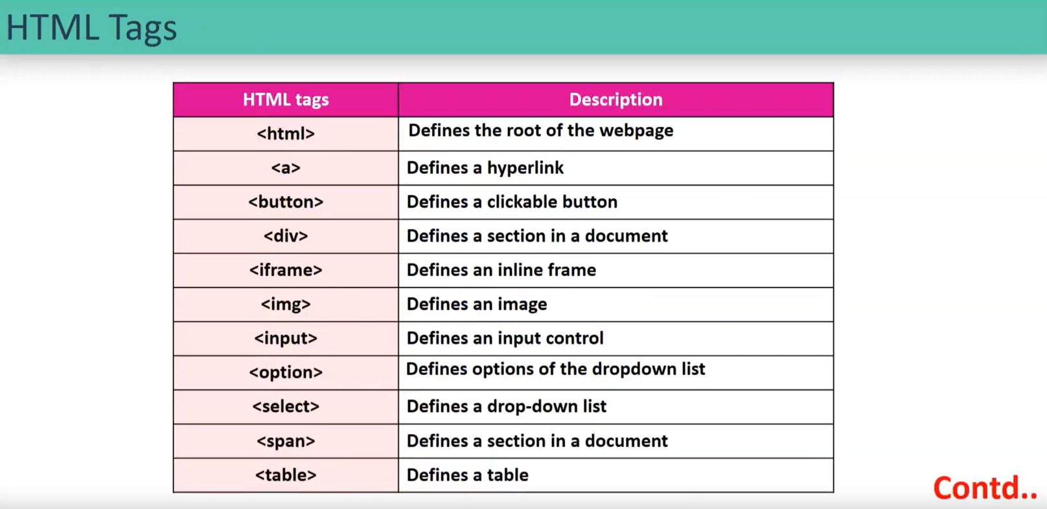

Attributes and attributes values

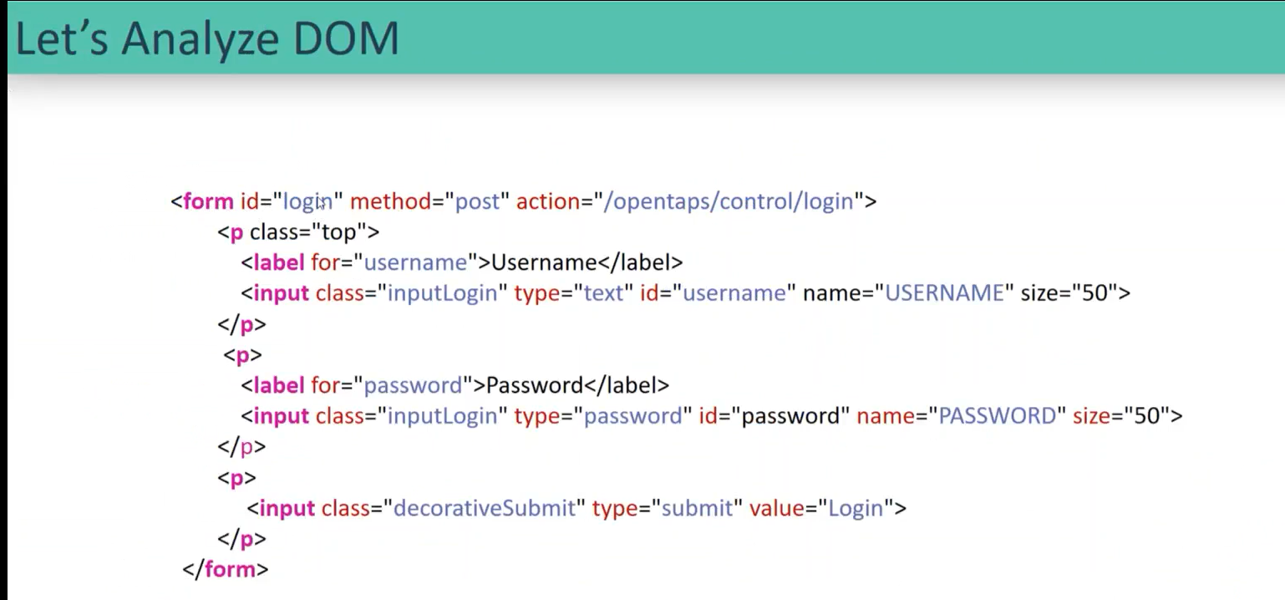

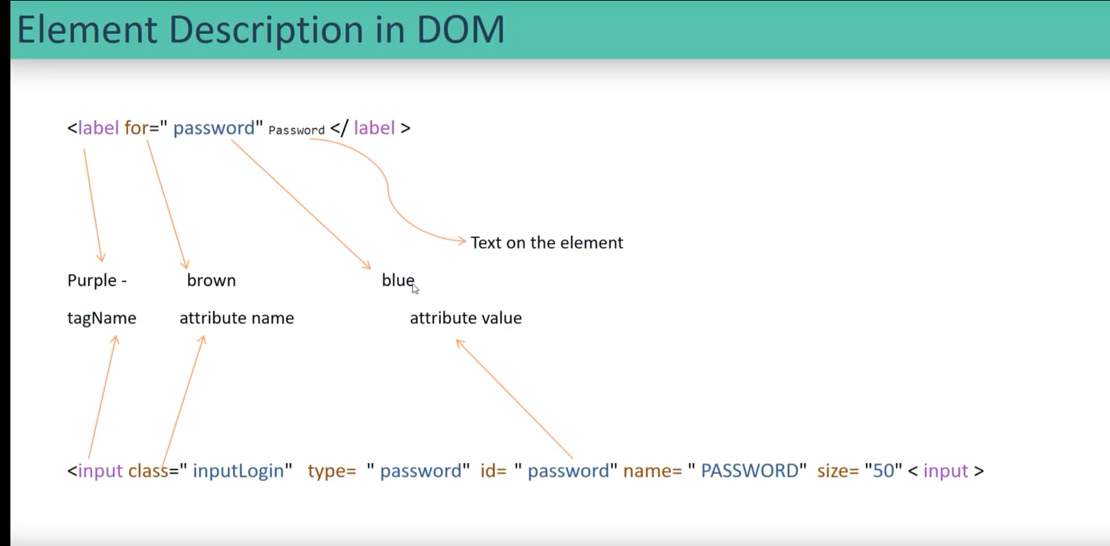

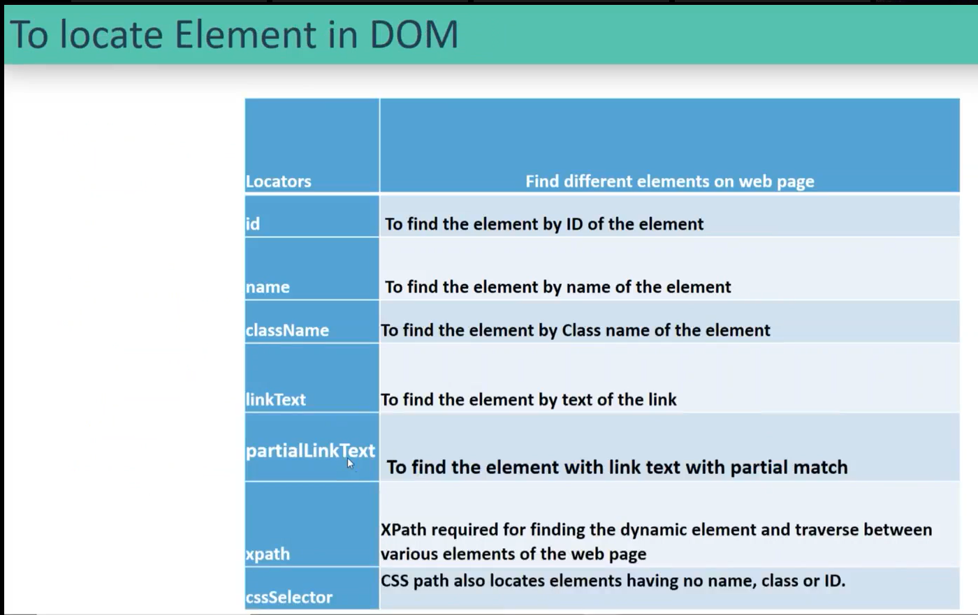

Locators:

Id attribute: priority.

If ID attribute is not there the “Name” attribute.

If ID and Name is not there, then “Class” attribute.

If ID, Name & Class is not there, then “Link text” attribute.

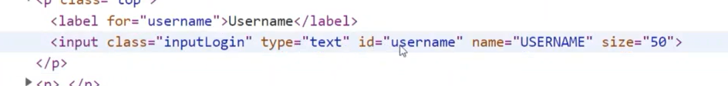

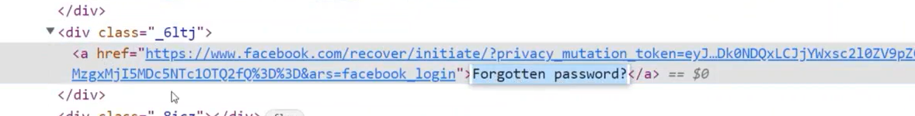

The text present in the ‘a’ tag is link text.

If name is not there, then choose the Classname.

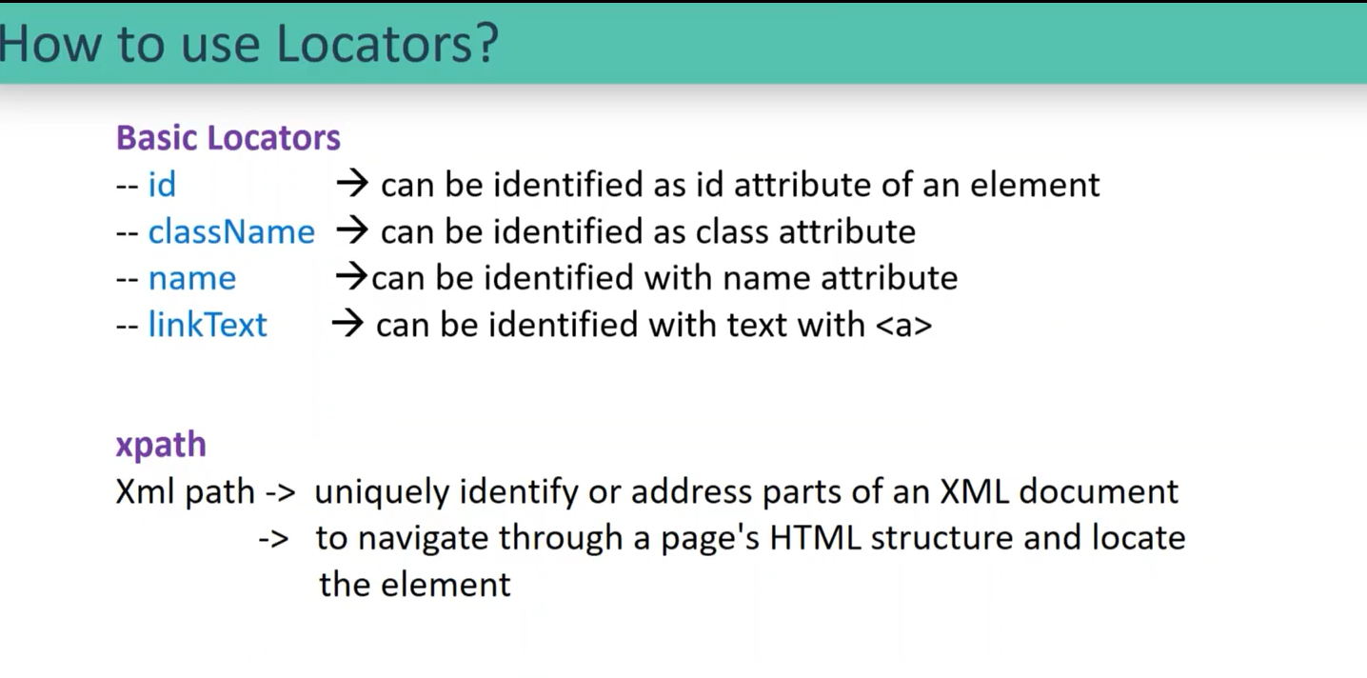

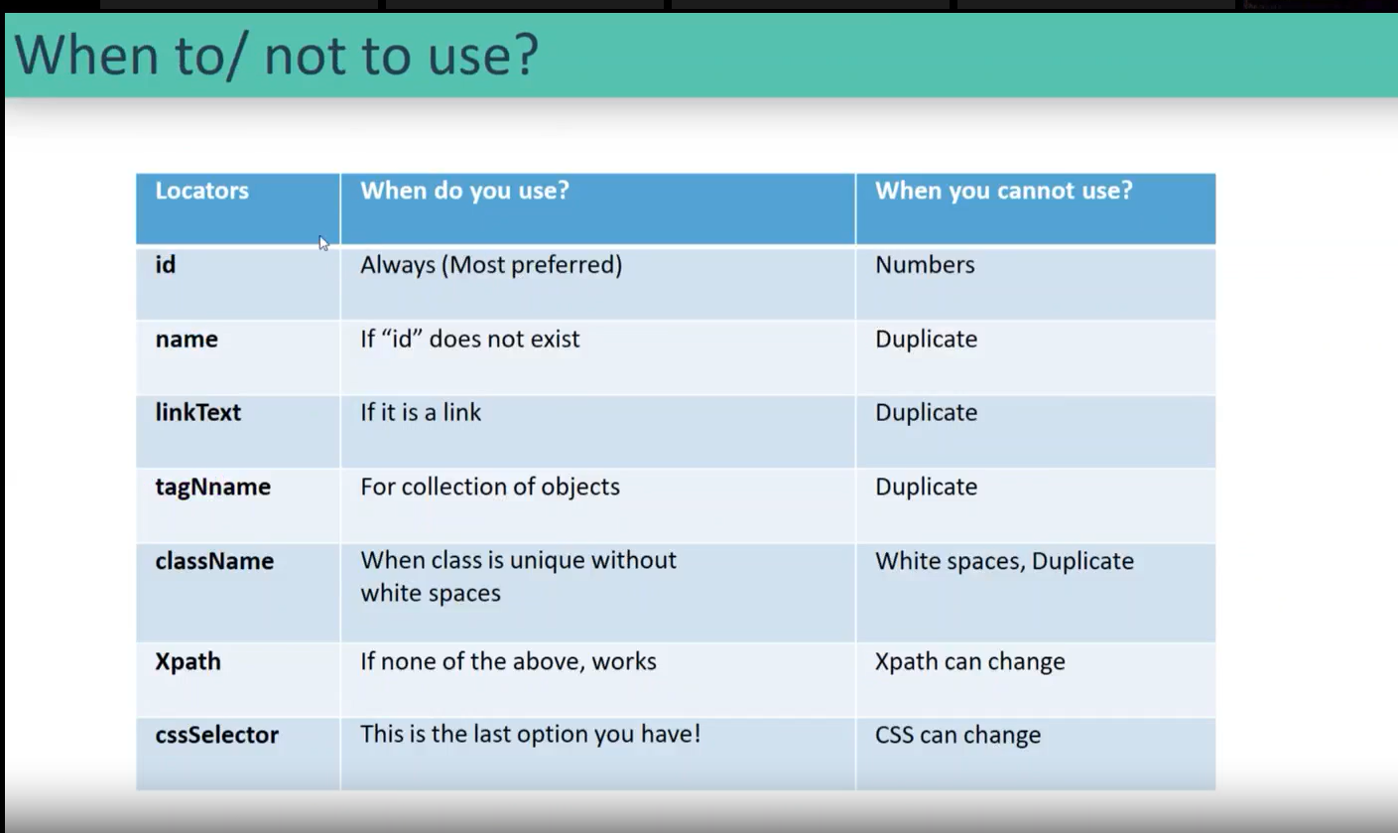

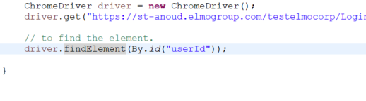

* Return type of findelement is Webelement.

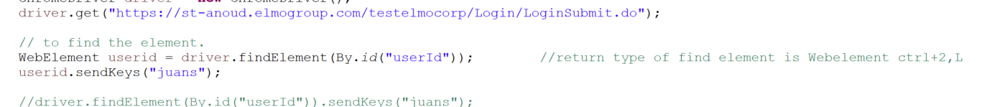

How to handle DROPDOWN in the scripts:

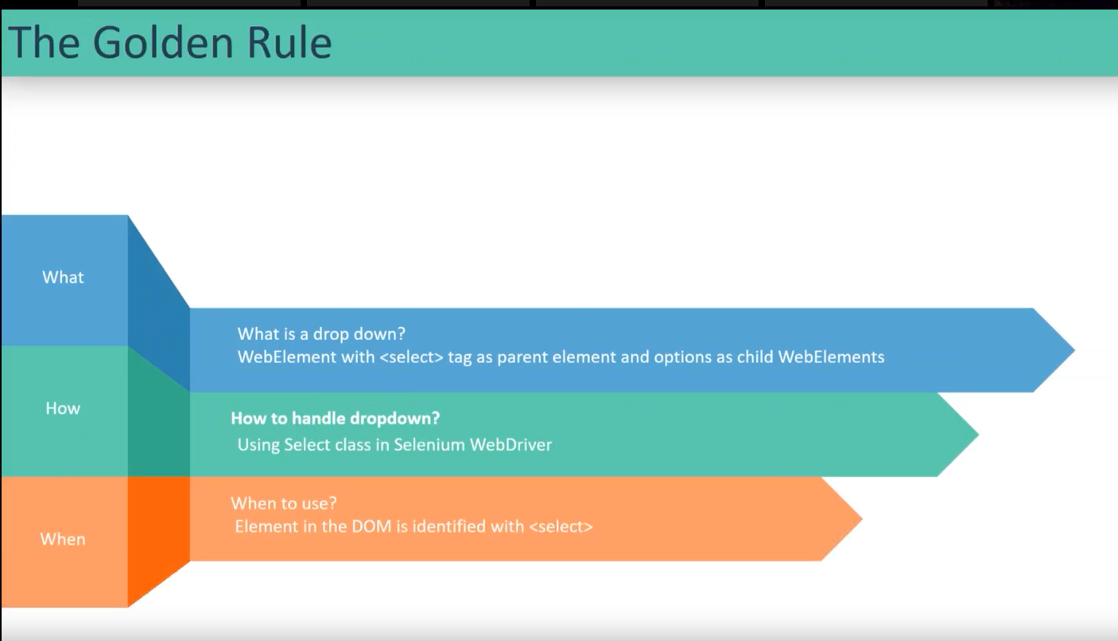

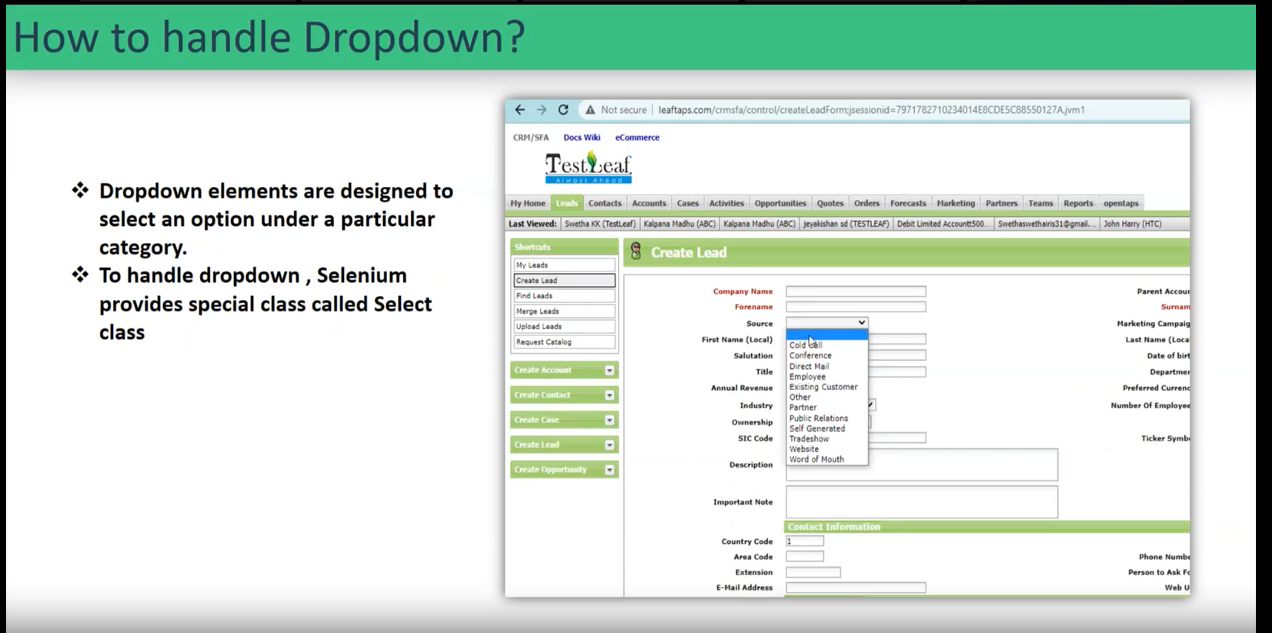

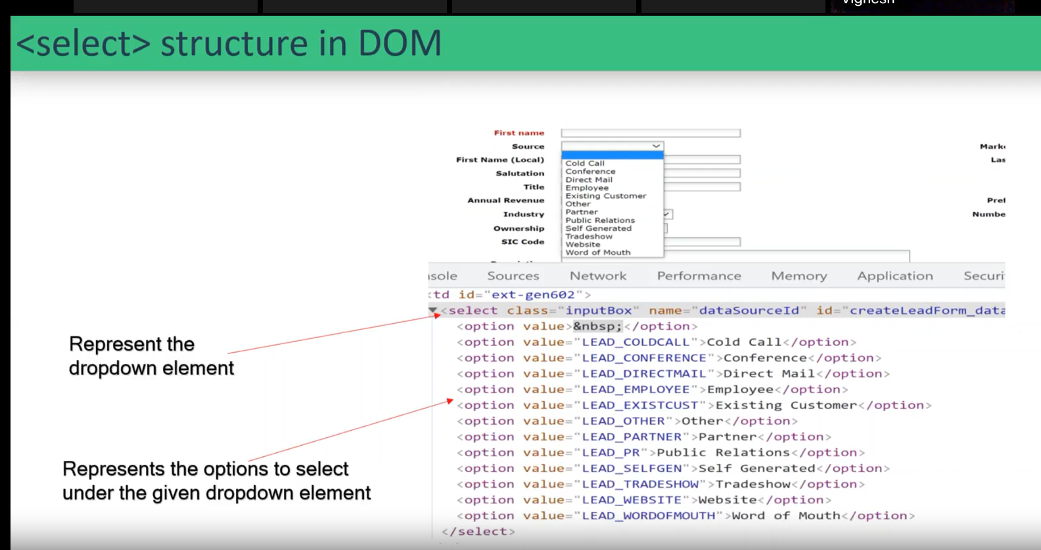

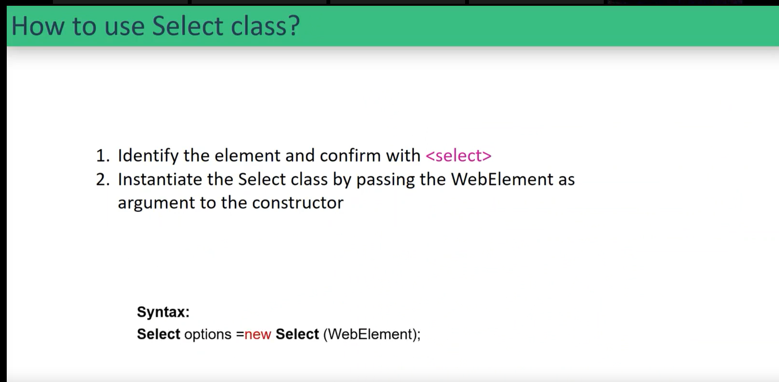

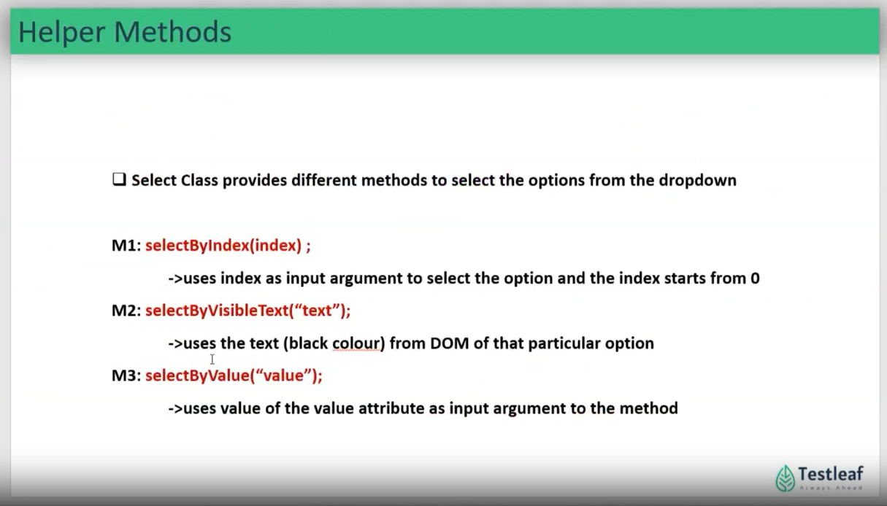

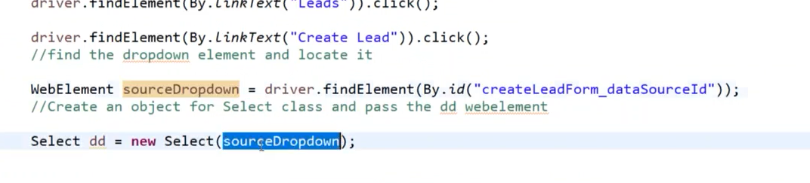

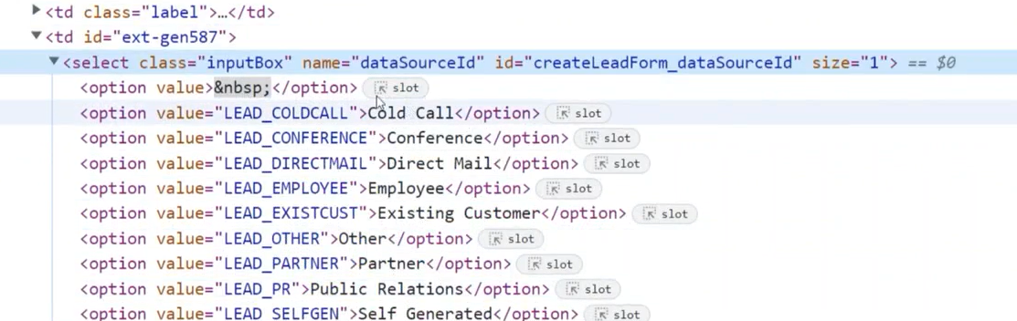

Visible by text is viewed in black text. (unique)

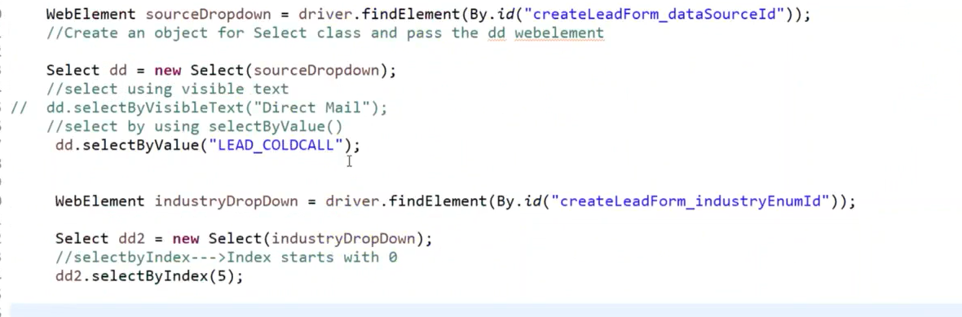

Recap

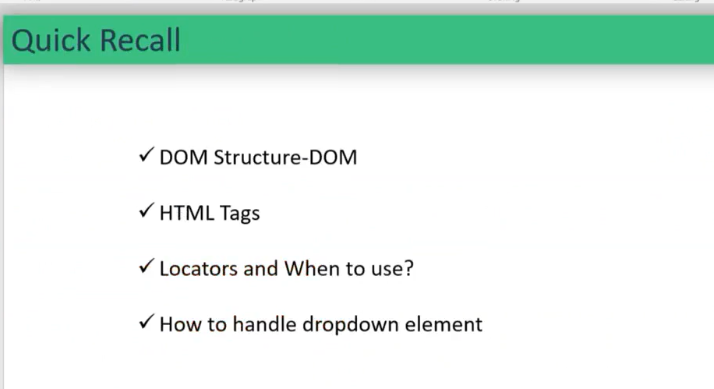

Selenium basics part 2

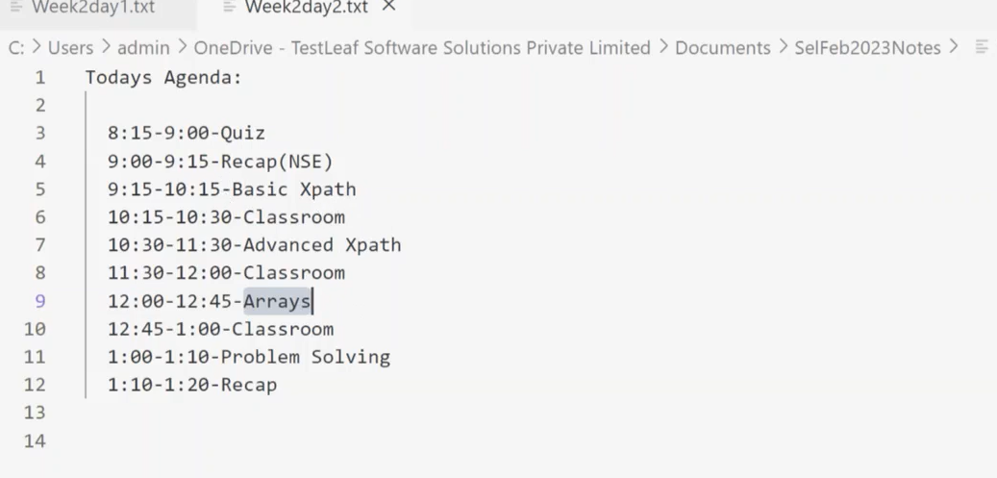

**X-path:**

Basic X-path.

X-Path is taken form the DOM.

When to use X-path

When the Basic locators is not available/ changes dynamically.

How to write X-path

Based on the X-Path and syntax.

Basic X-path and Advanced X-path:

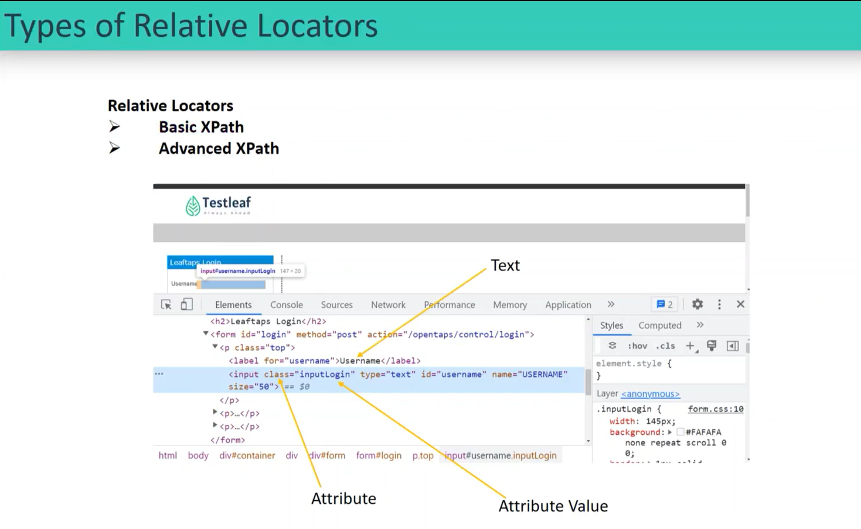

Basic X-path:

In the basic X-path we have 2 types.

* + - Absolute X-path.
    - Relative X-path.

**Absolute X-path.**

* It should start with the “/” (single slash).
* It should start traversing form the Route Tag.
* Tag name is very mandatory.
* It is not preferred.

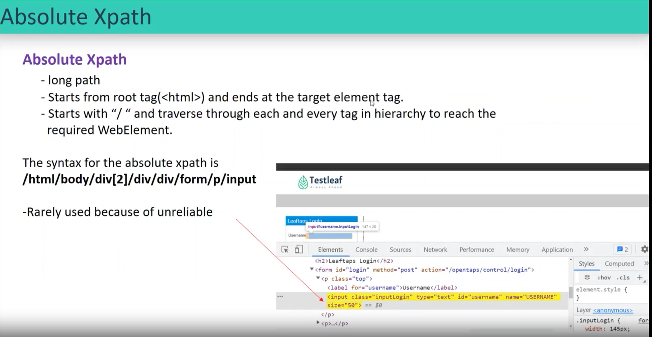

Syntax: /html/body/each route……

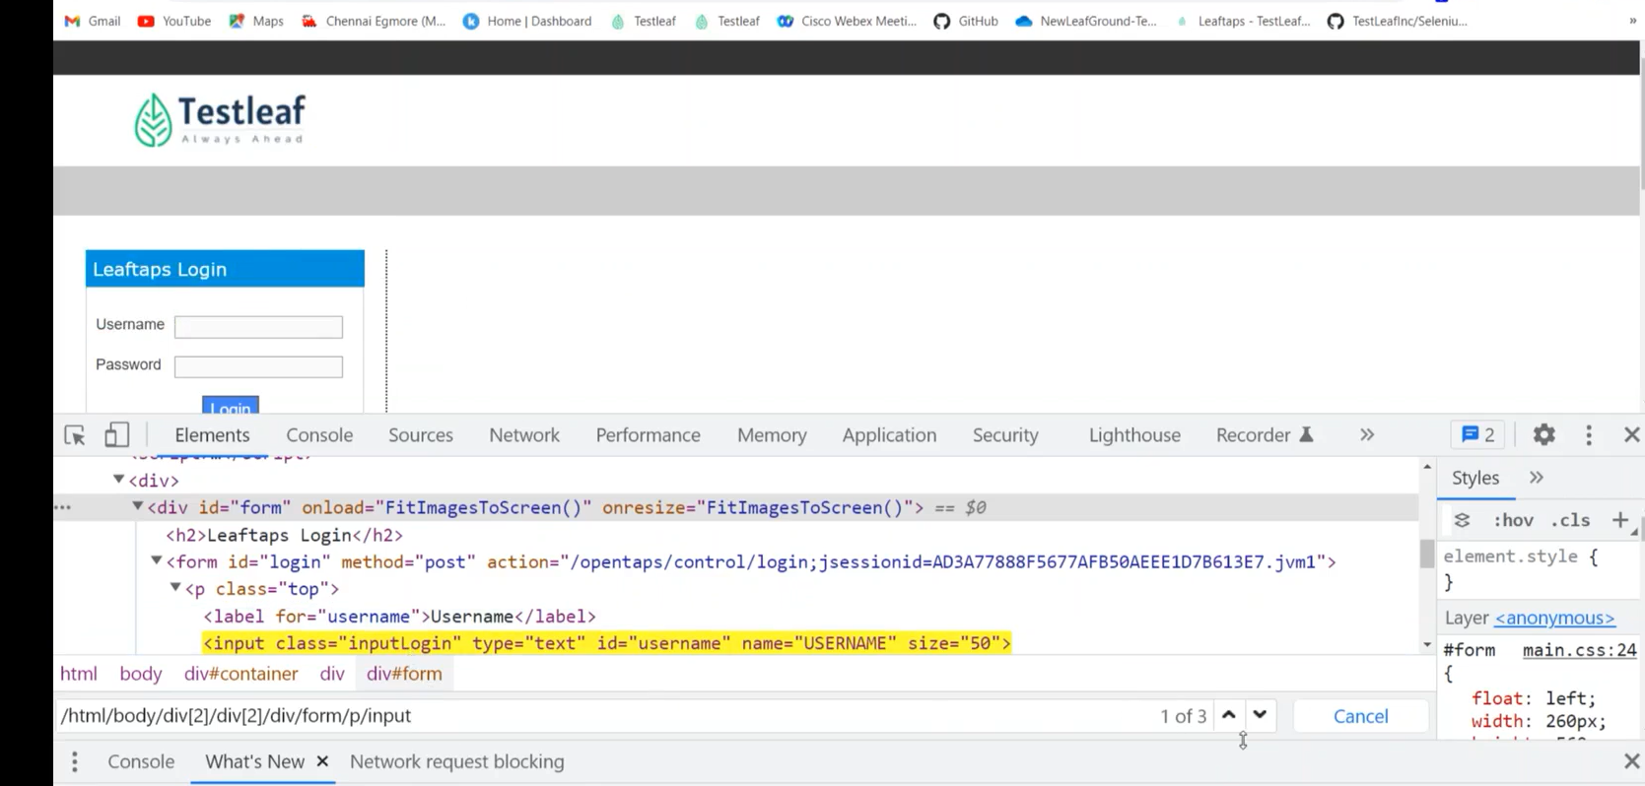

When I wrote an X-path, it will choose the first matching element, if we didn’t mention any index.

With duplicates.

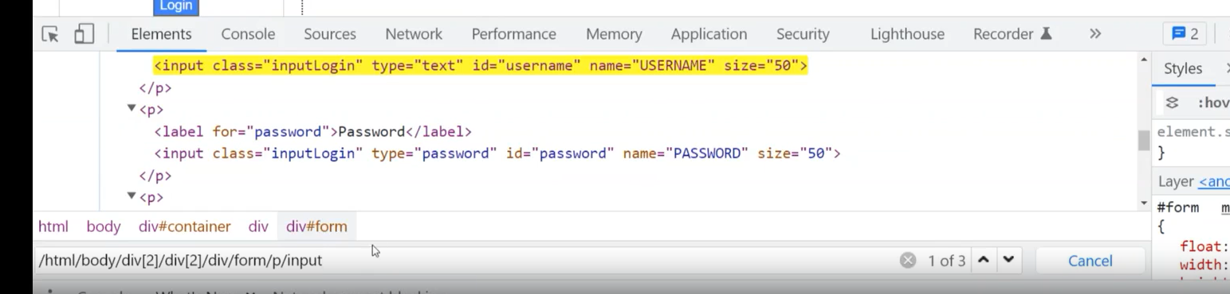

**Relative X-path**

* It should start with the “//” (Double slash).
* Tag name is very mandatory.
* There are 5 types of x-paths that locate an element using different ways of x-path.

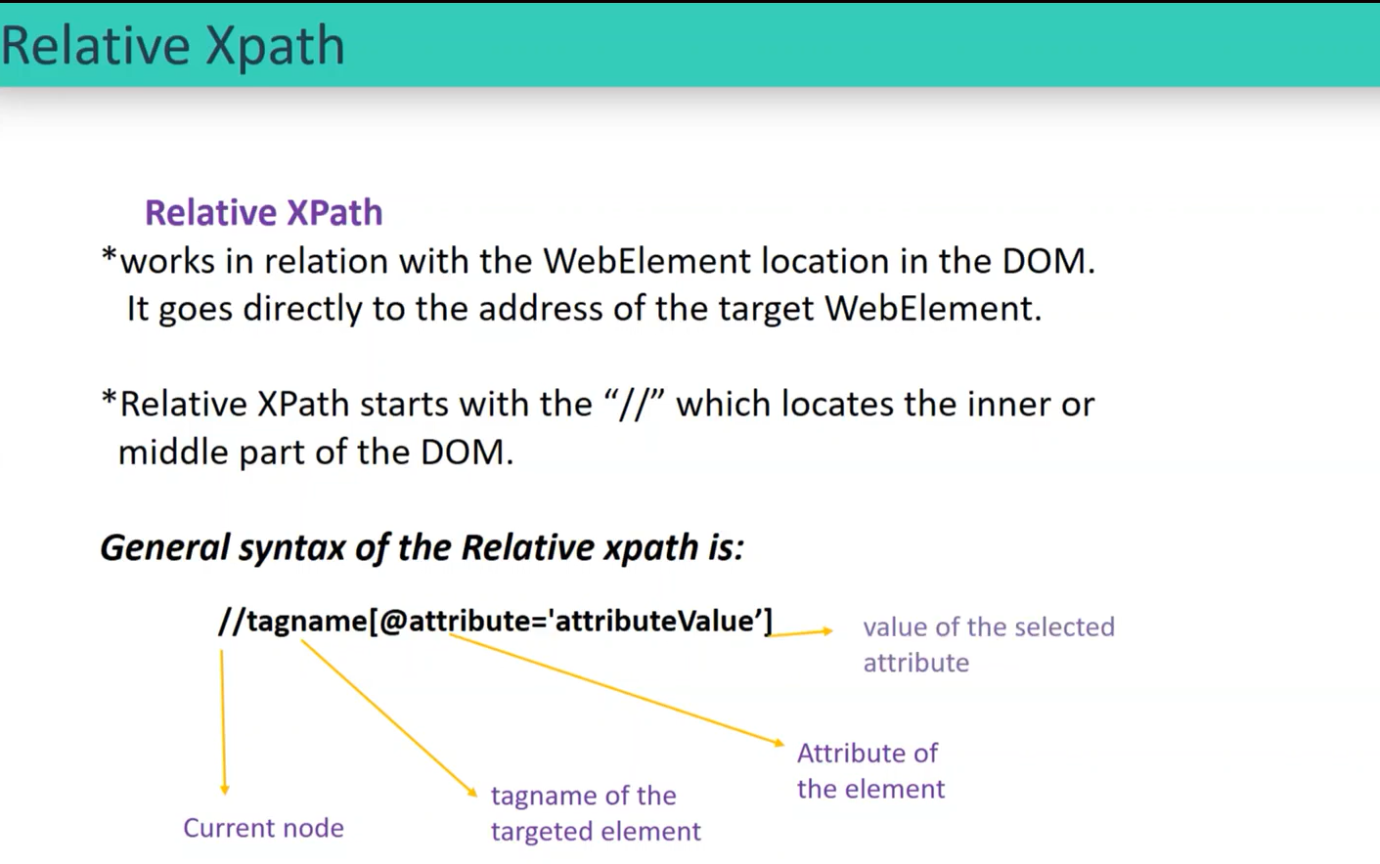

**5 ways of basic x-path**

* **Attribute based X-path**

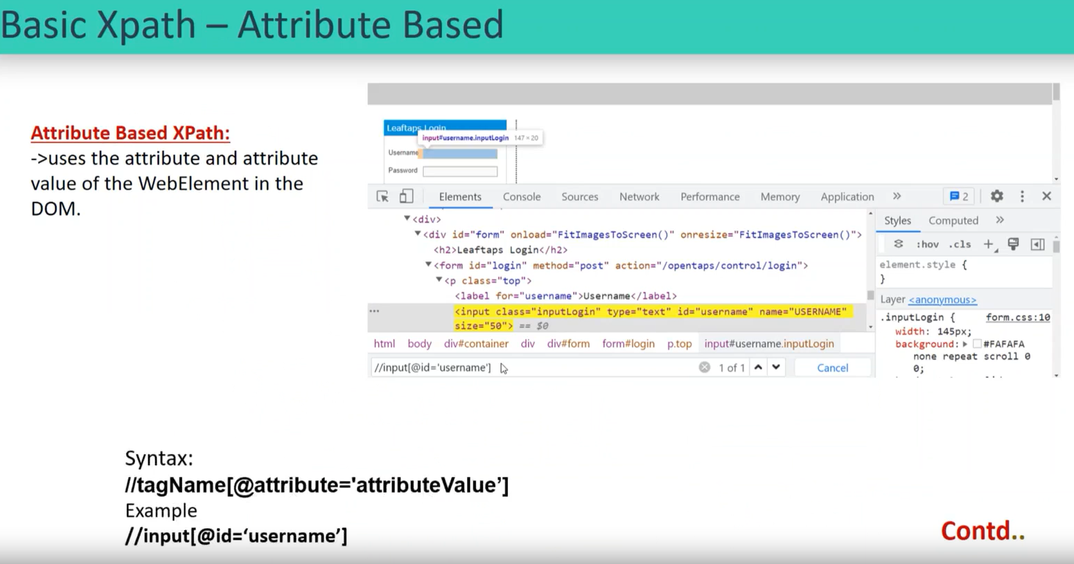

Syntax: //tagName[@attributeName=’attributeValue’]

Ex: //input[@id=’username’]

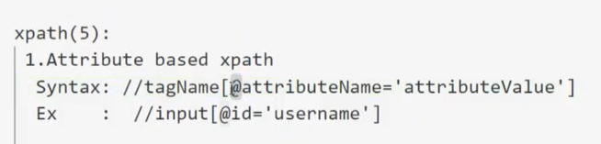

* **Text Based X-path**.
  + - (If text-based x-path @ is not in use)
    - If the black text is not at the label ‘a’ then the x-path would be the Text based x-path.

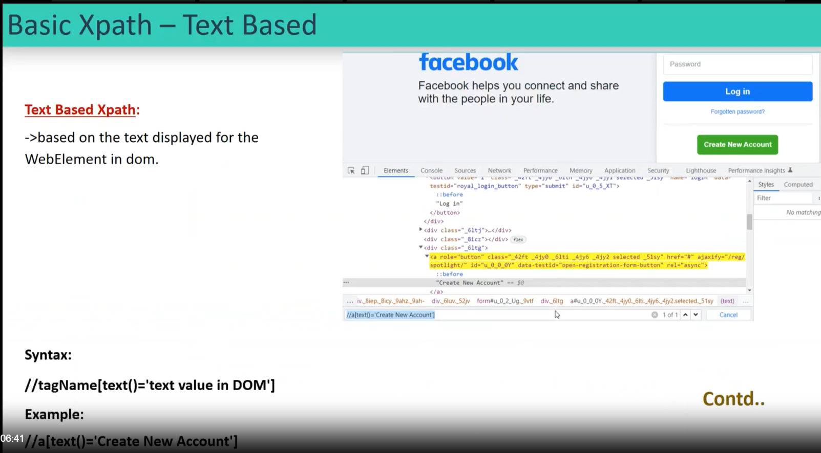

Example:

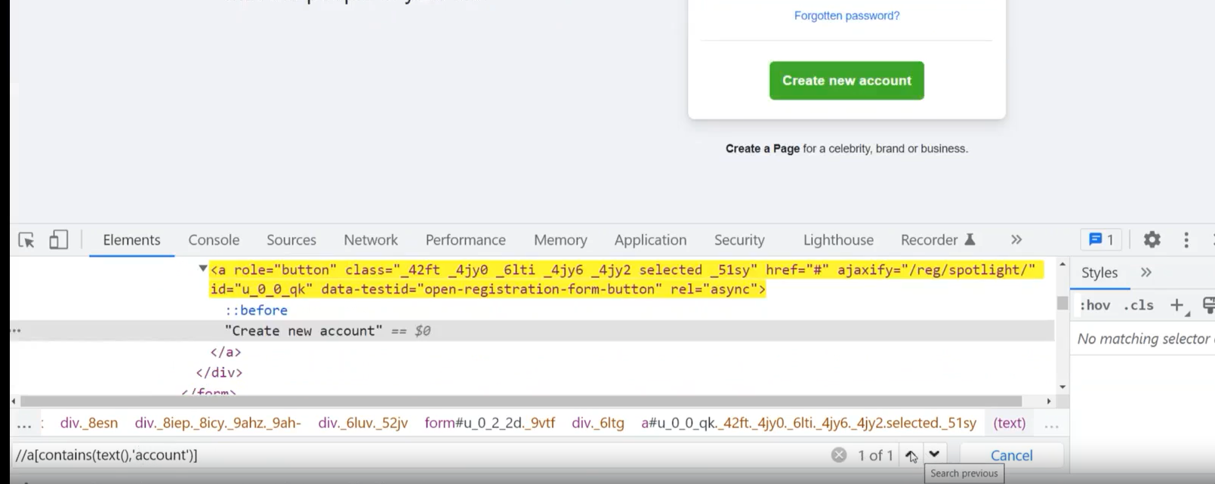

Syntax: //tagName [text () =’textValue’].

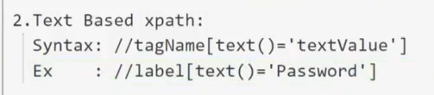

* **Partial Attribute based X-path**:

When the attribute value is too long then we would choose the partial attribute x-path.

Partial AttributeValue= Value can be taken any either middle/first/last in the value.

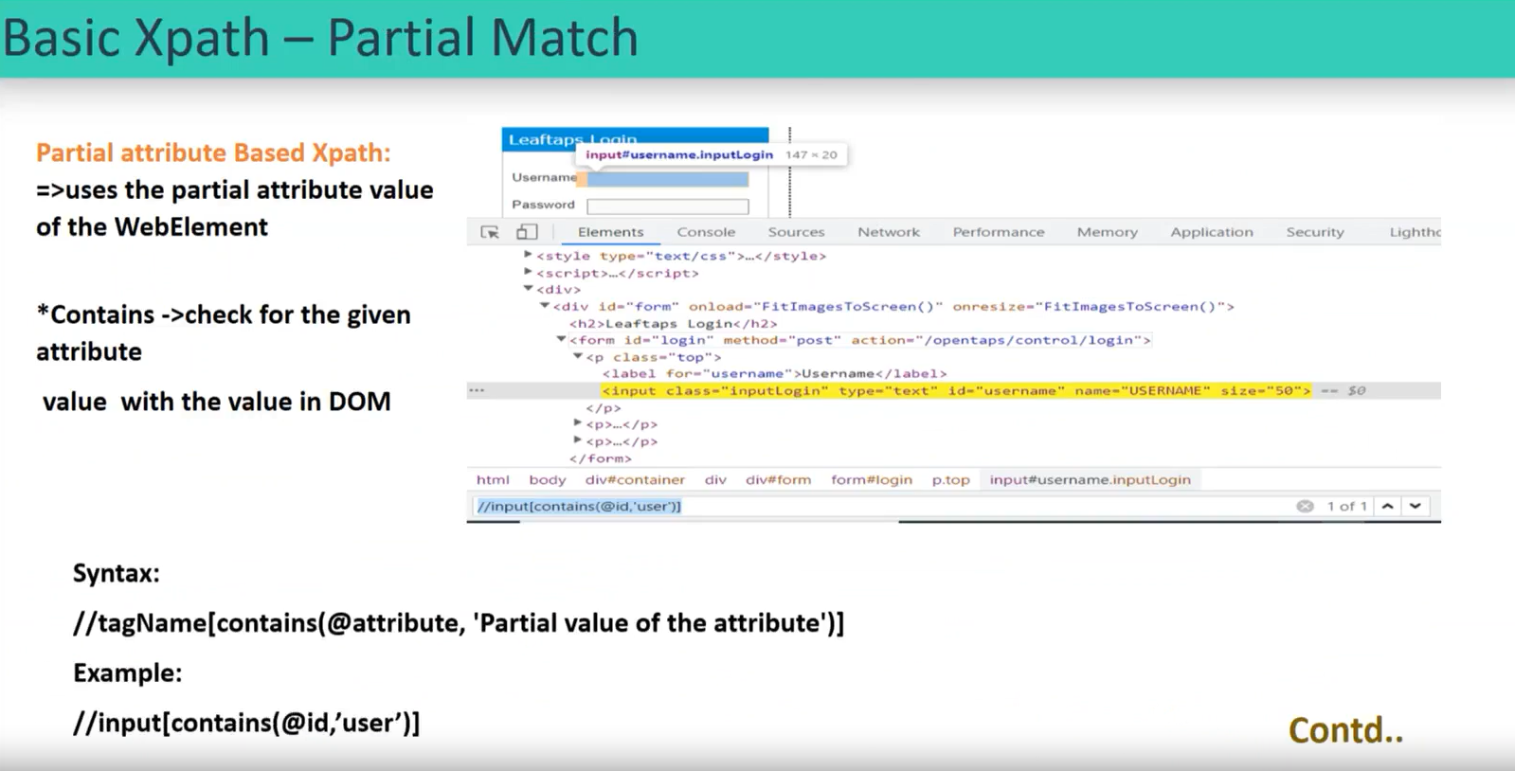

Syntax: //tagName[contains(@attributeName, ‘partialAttributeValue’)]

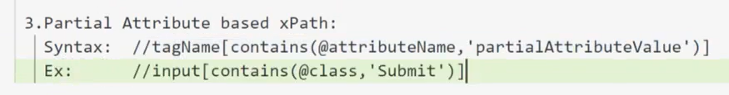

* **Partial Text based X-path**:

Like **Text Based X-path** as expected.

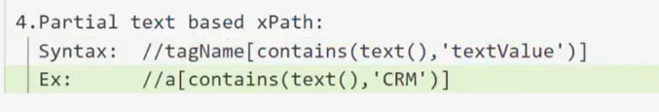

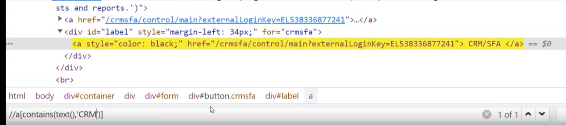

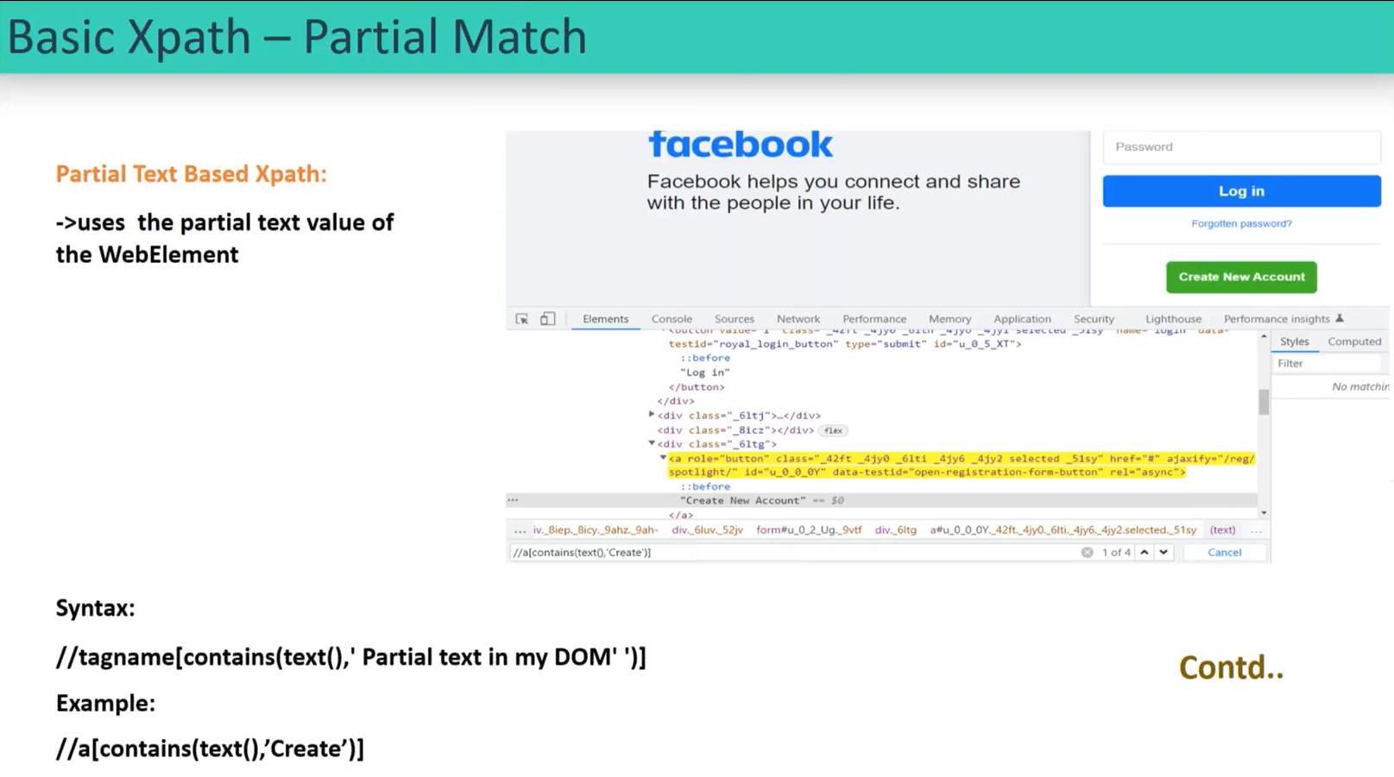

* **Index Based X-path:**

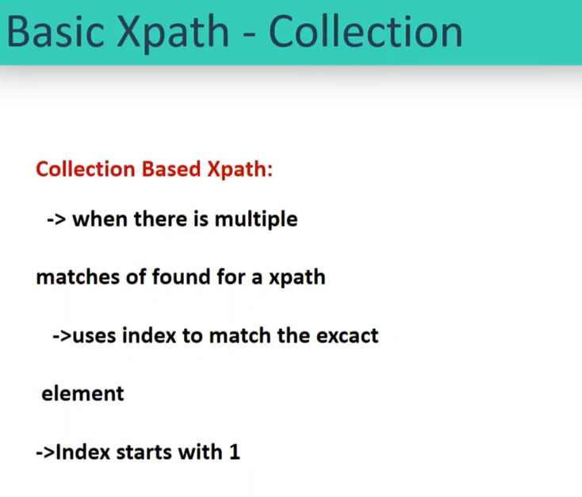

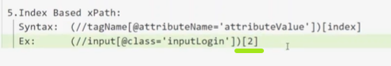

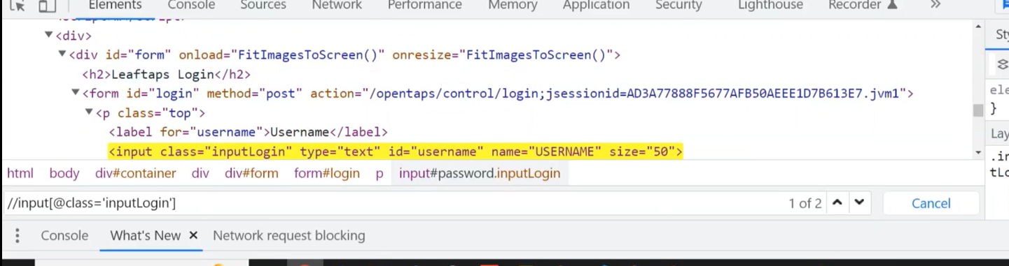

Classroom task:

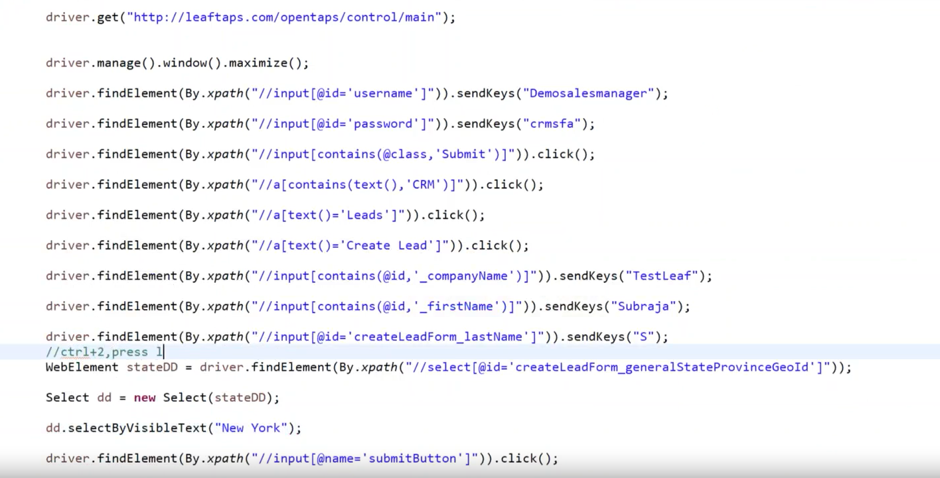

Advance X-Path: (Relationship based X-path) 8 level of x-path:

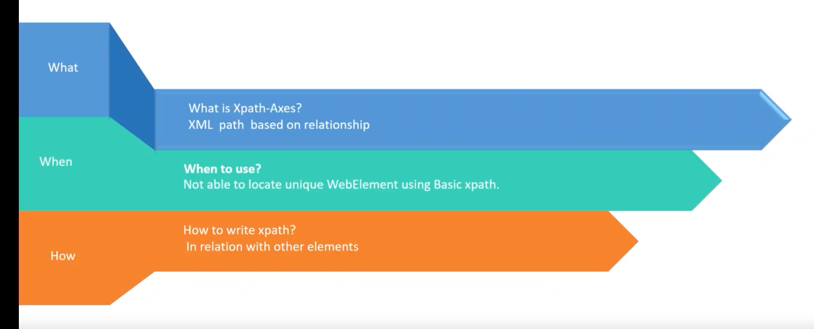

1. Parent to child:

Syntax: basicX-pathforparent/childtagname

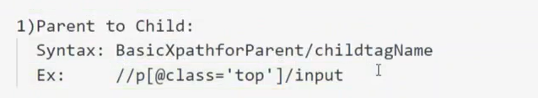

1. Child to parent:

Syntax: basicX-pathforChild/parent::parenttagname

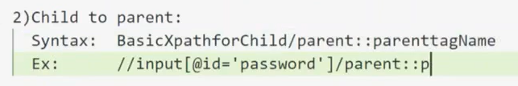



1. Grand parent to Grand child:

Syntax: BasicXpathforGrandparent//grandchildtagname

one by index other by exact attribute.

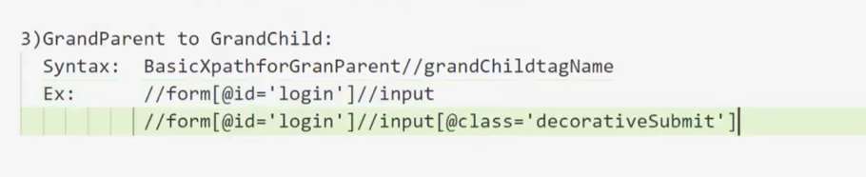

1. Grand child to Grand parent:

Syntax: basicX-pathforGrandchild/ancestor::grandparenttagname.

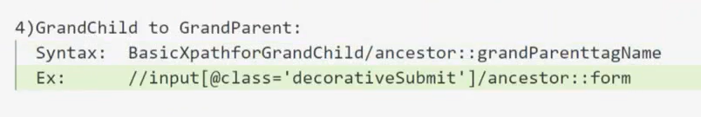

1. Elder Cousin to younger Cousin:

Syntax: X-pathforEldercousin/following::youngercousintagname

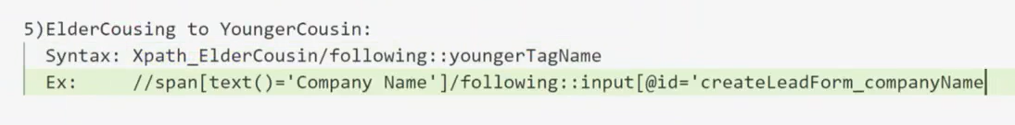

1. Younger Cousin to Elder Cousin:

Syntax: X-pathforYoungercousin/preceding::Eldertagname

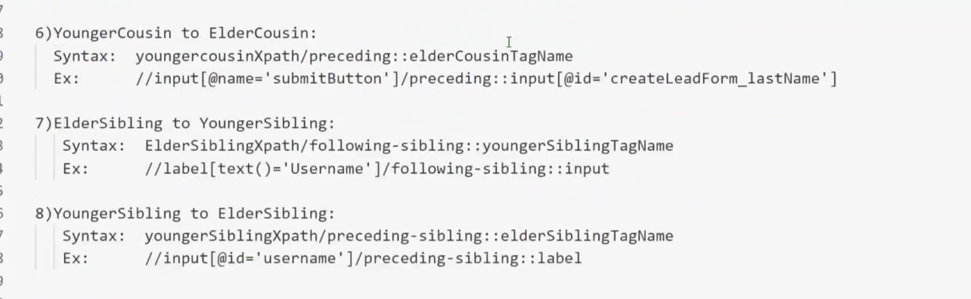

Week 4 day 1

Target Locators: the elements or any context which cannot be handled like a Webelement (these are the special areas that are going to be handled).

3 types of locators: Alert/ Frame/ Window.

Alert:

If we see an alert, we should take an action and on the same do not skip/ignore it.

When an alert is on, the entire DOM, or other Webelement will be frozen.

We have only one alert at a time, can’t have multiple alerts at a time.

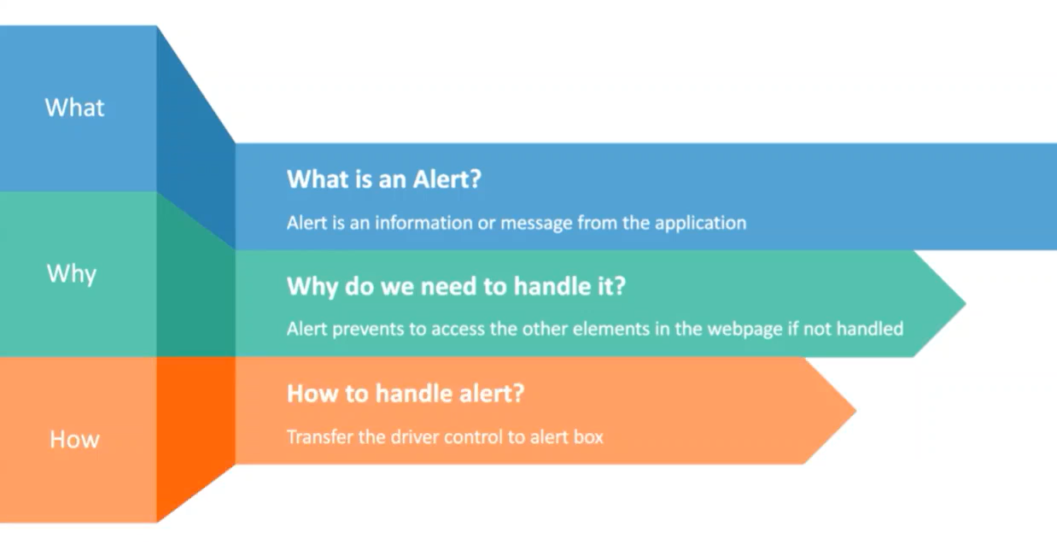

1. Website alerts can’t be automated.

Eg: wwwtestleafsays an alert

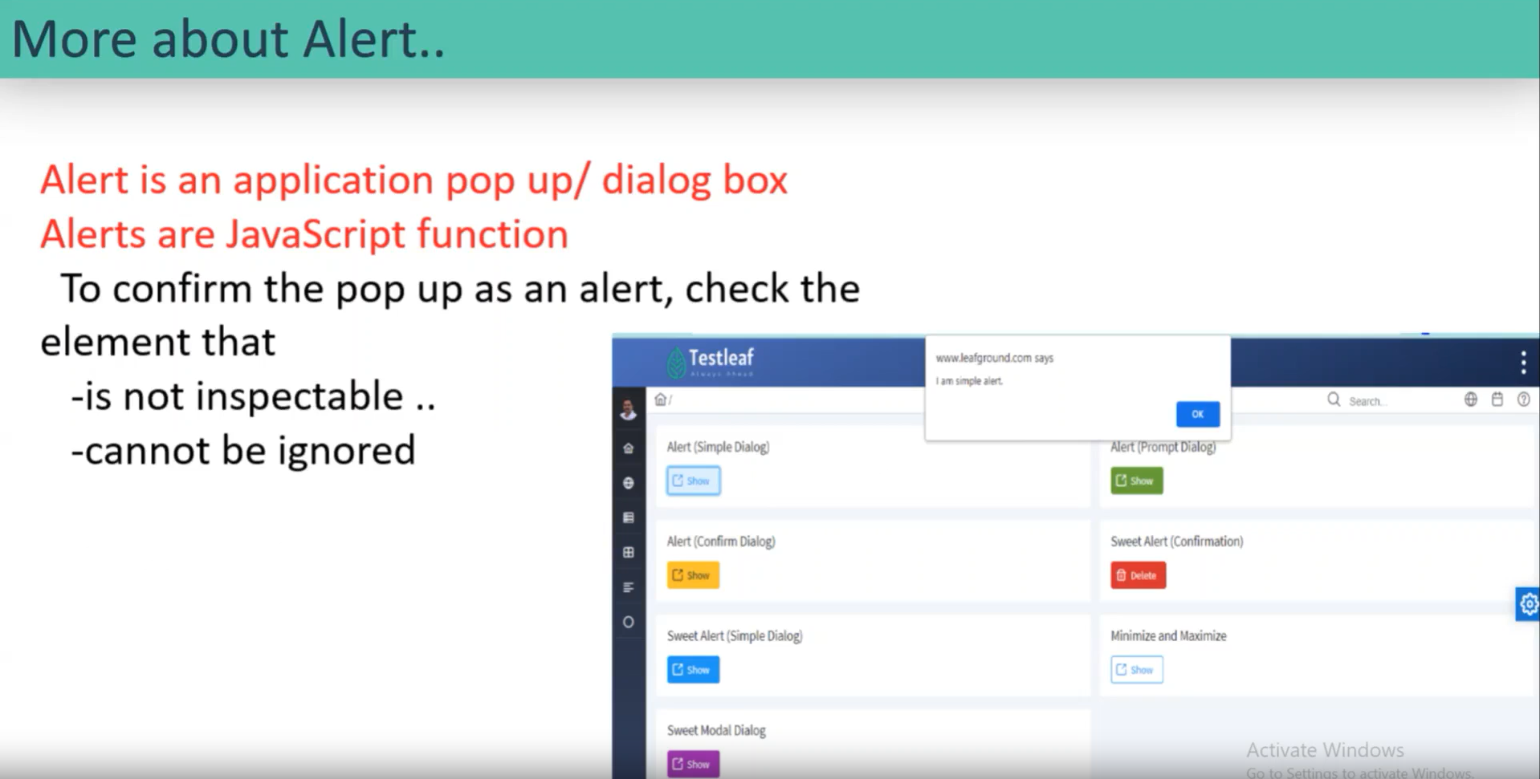

1. What can be handled:
2. Website alerts with a text can be automated as stated in the above pic.
3. It can be one or two buttons, either yes or no / ok buttons using automated.
4. If a check box is there to click, that can’t be handled.
5. If there is a close(x), that can’t be handled.

Just to know:

* all the alerts come from a JS function. It is not an Webelement.
* To confirm the pop-up as an alert, check the element that is not inspect.
* Function(method).

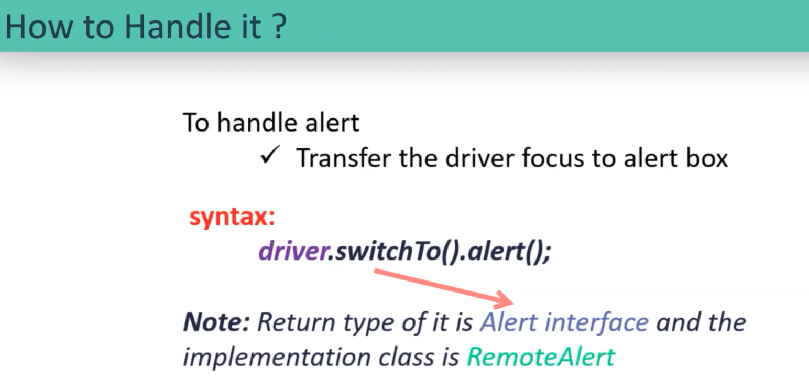

If I use it my context form the webpage is moving to the alert.

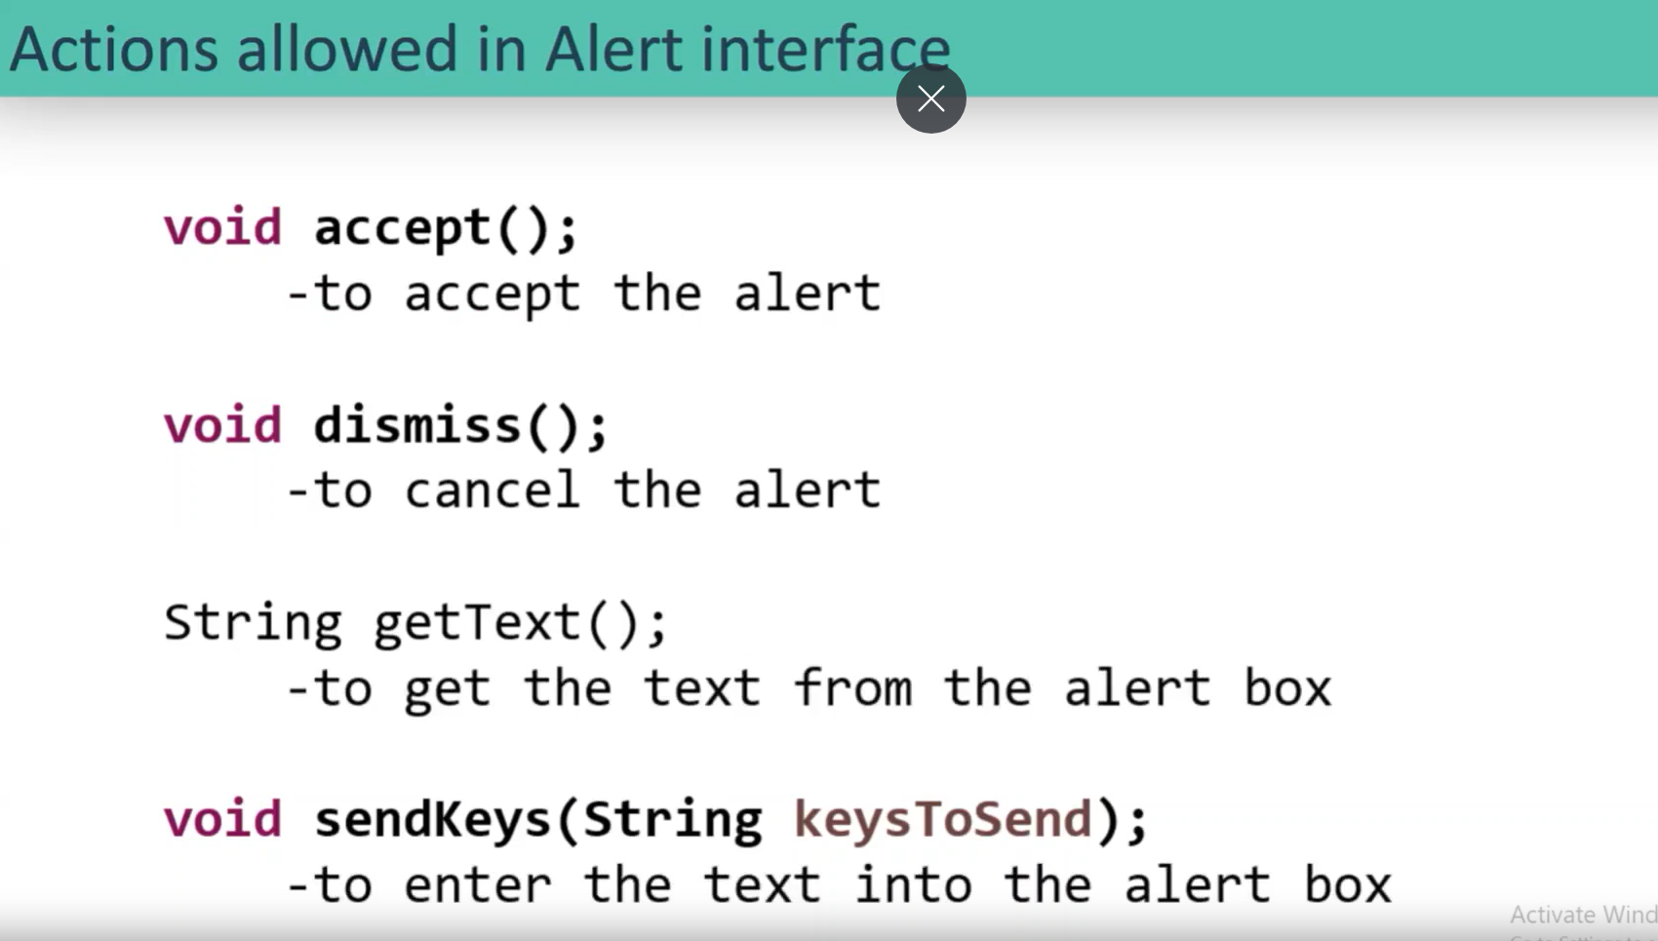

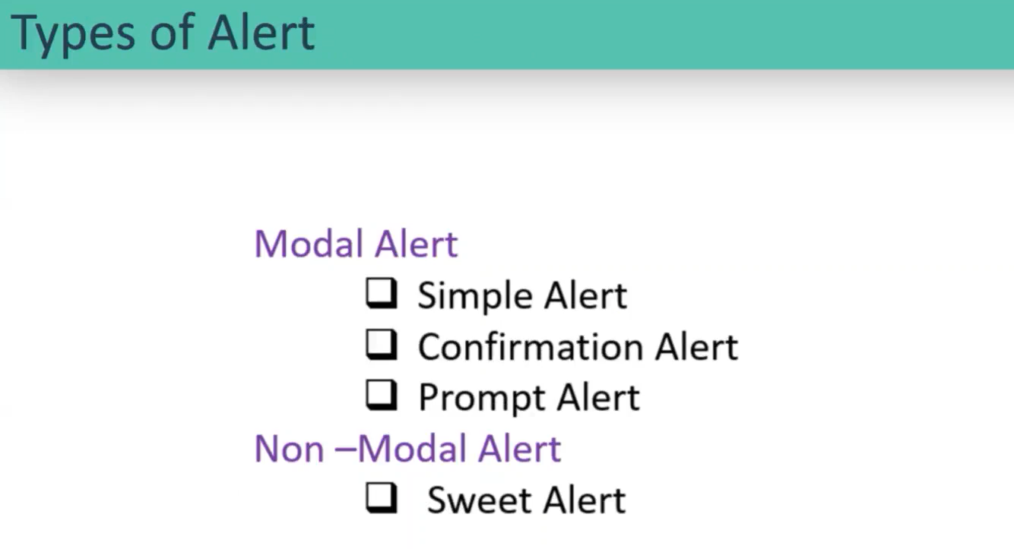

Modal alerts are the latest alerts:

Simple alert come with only text and ok button and should say ok.

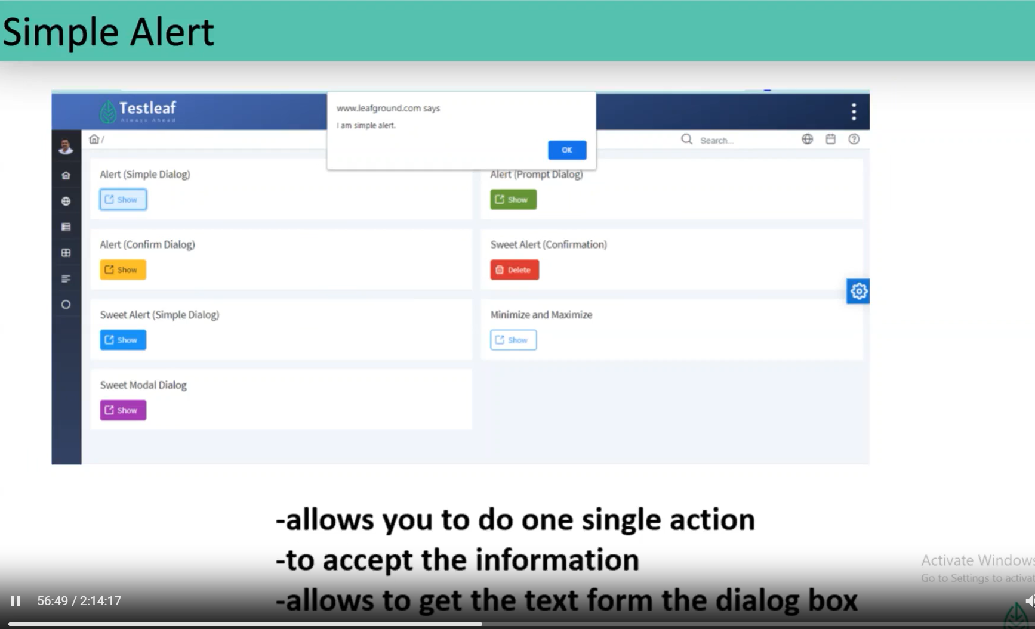

Confirmation alert comes with an option along with the text as YES/NO, OK/Cancel buttons.

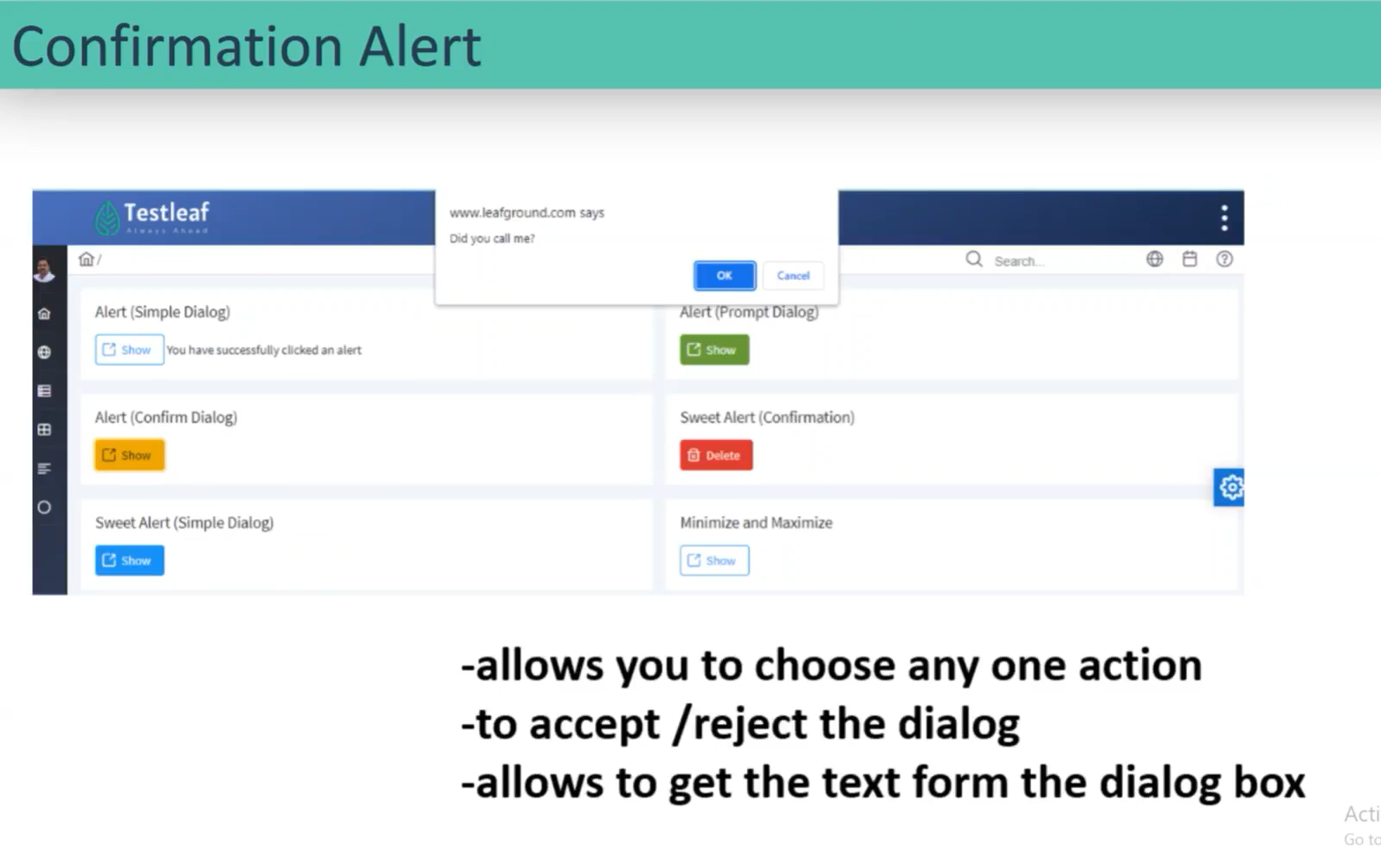

Prompt alert when we give some inputs to the alert.

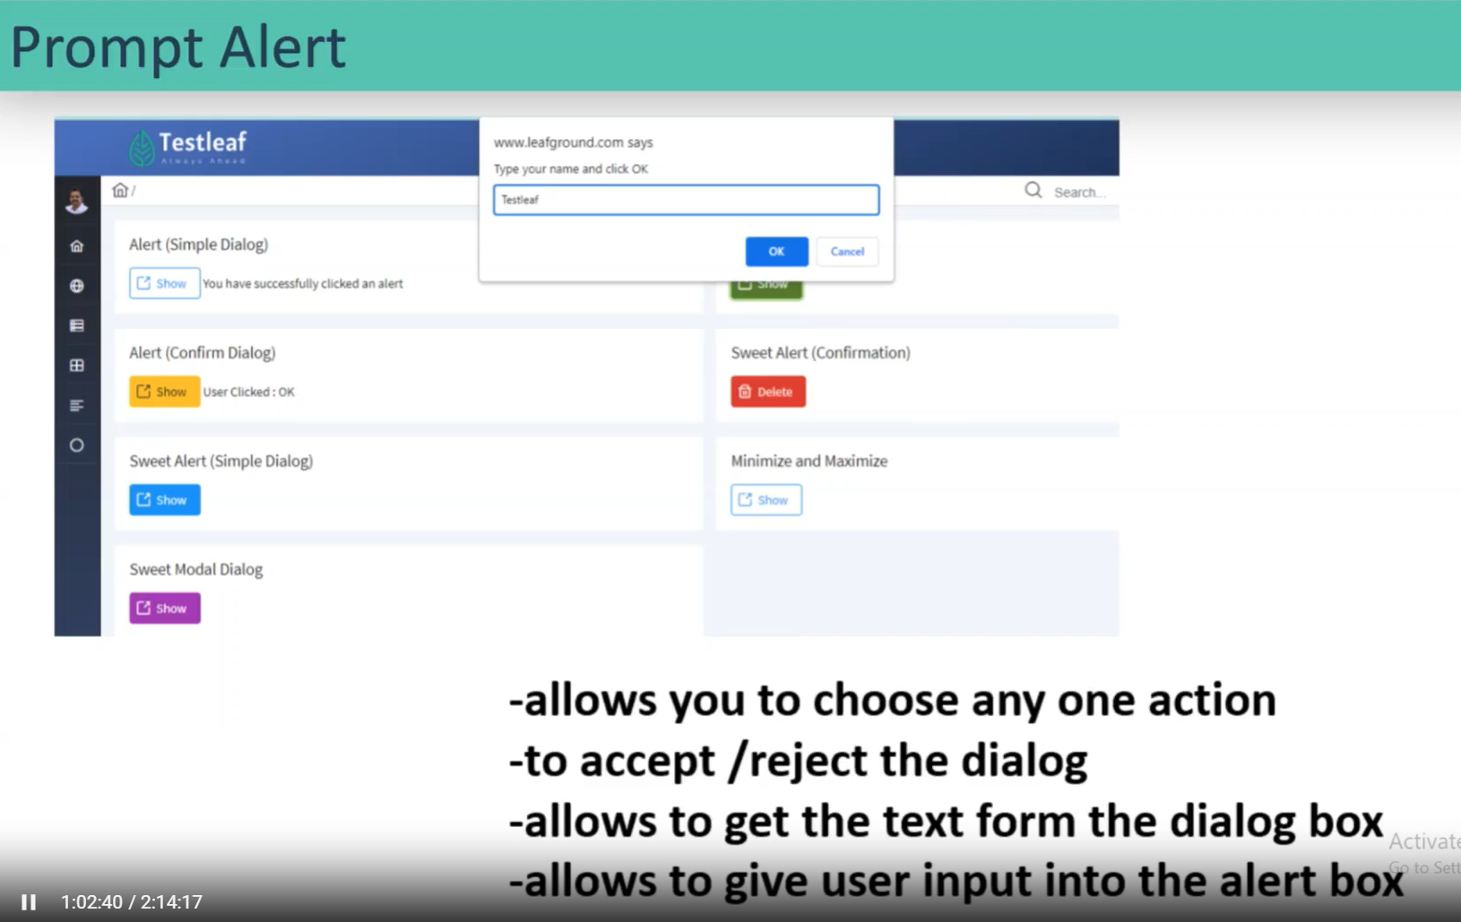

Non-model alert/Sweet alert:

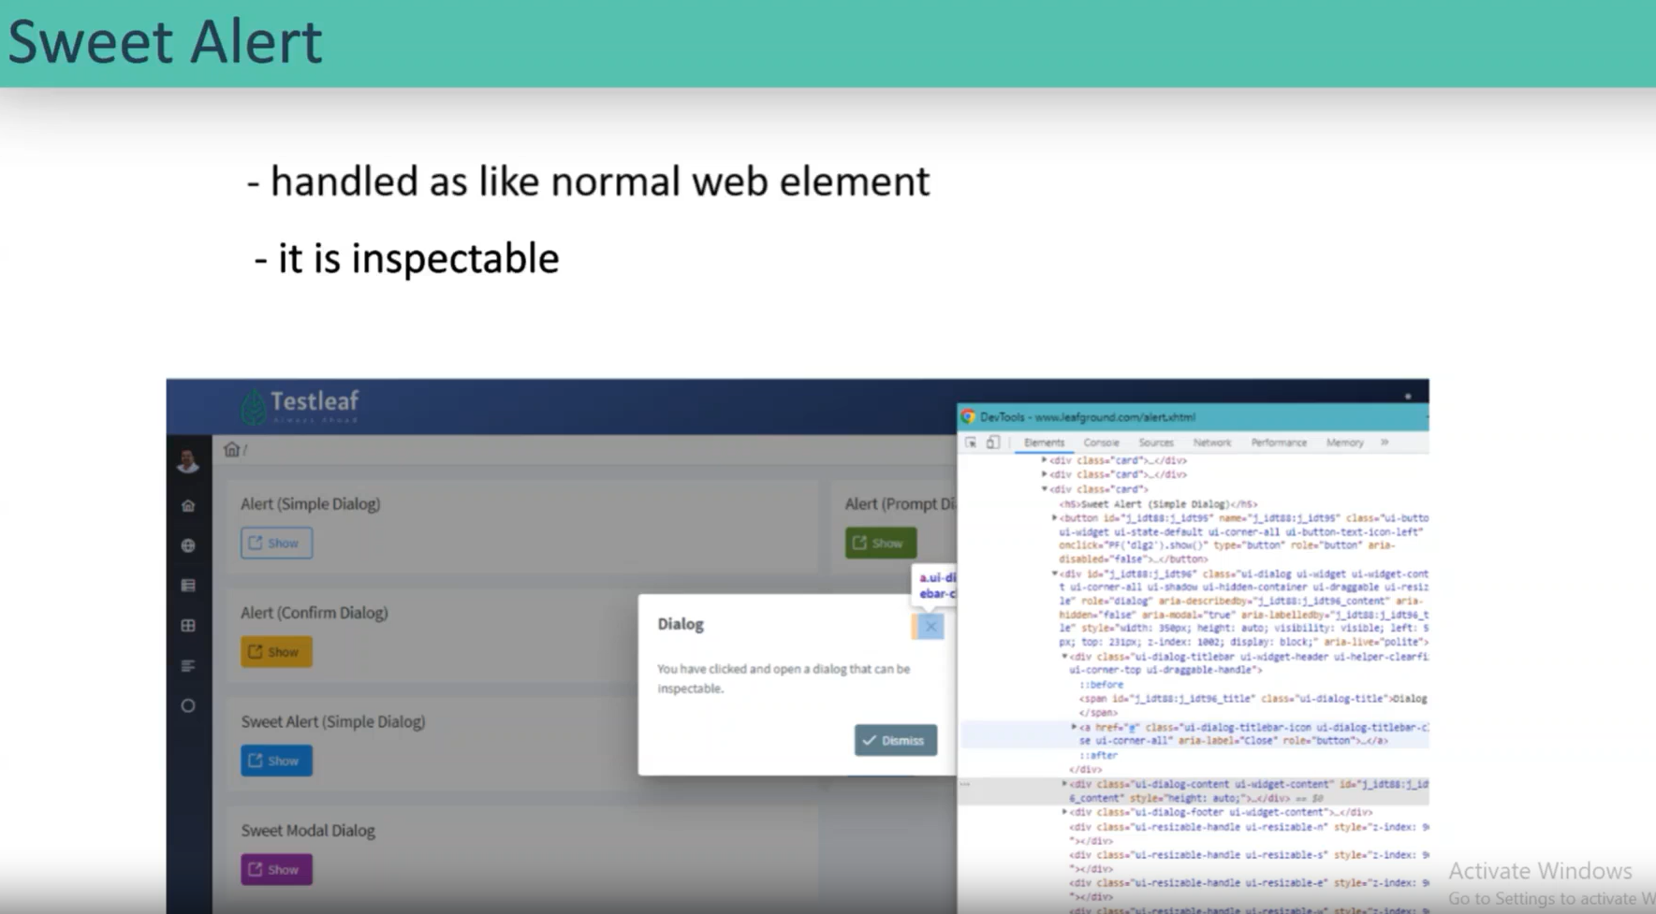

.. in the X-path it will direct the parent.

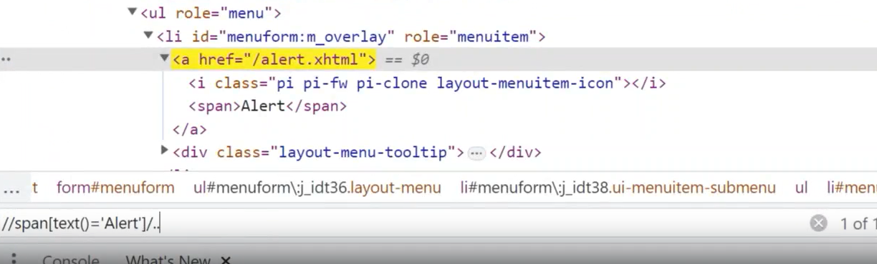

Alert alert = driver.switchTo().alert(Ctrl +2.L);// alert is an interface- have an implementation class-> remote alert is the implemantation class of alert interface

String text = alert.getText(); // displys the text your naem and click ok

//System.out.println(text);

alert.sendKeys("puneeth"); // could nor able to view the text enter on only the alert.accept only it would display the text:

alert.accept();

Note:

* if we want to enter or get the text that should be done before to the accept or dismiss the alert.

* Exceptions we will get in an alert.

* 1st exception: unhandled alert exception. (unhandled alert means ignoring the alert)

* 2nd exception: no alert present exception. (taking precautions for the unwanted alert)

Frame: is a partition in main webpage/ another HTML page.

The “//I frame” is a tag in HTML that helps the user to create sub-HTML. inside the I frame also there is another HTML page.

In inspect search for “ Iframe” then we can find the count of frames in the page.

Inside frame:

Inside Nested Frame:

How many no of frames:

understanding: in a webpage, a particular page is allocated for Ad’s.

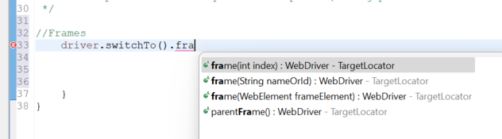

I will an error when I try to find a element out to the frame without switch to frame then I will find an exception error.

Getting out of the frame: driver. Switch to (). defaultContent ().

If to get the exact frame form the n num of frames, then we should do the below:

* Using string we have to take to 2 attributes 🡪 class / id.





Windows:

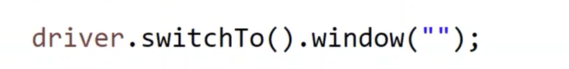Duplicate tabs and pop-up windows are both same in selenium/

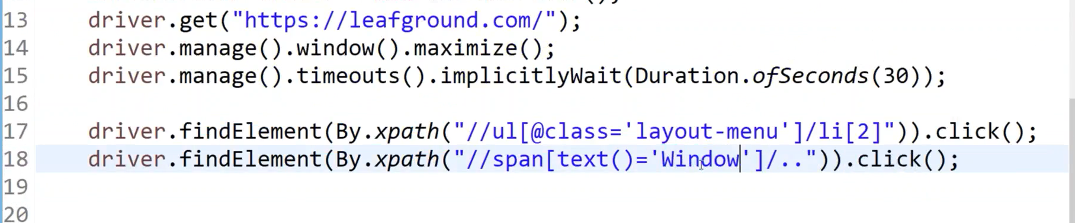

In selenium they have written a code to identifier to each w

getwindownhandle() will generate an unique id for a window on current session, if u change the session it will generate an another unique id for the current session. It is purely generated by the selenium.

Getwindowhandles(); will get u the both the windows in multiples string then it cannot store in string, then we have to array of string but it should be user as collections of set. linkedhashset.

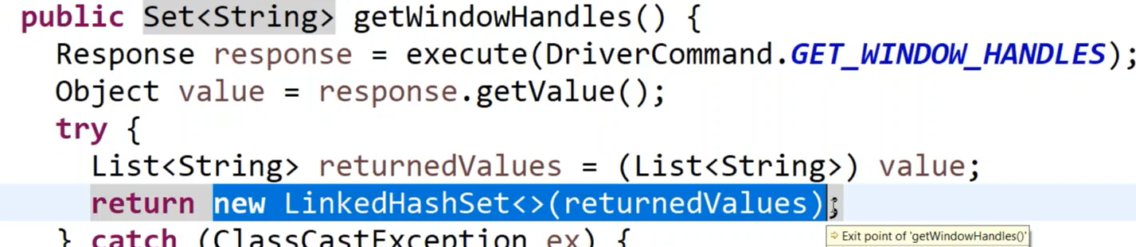

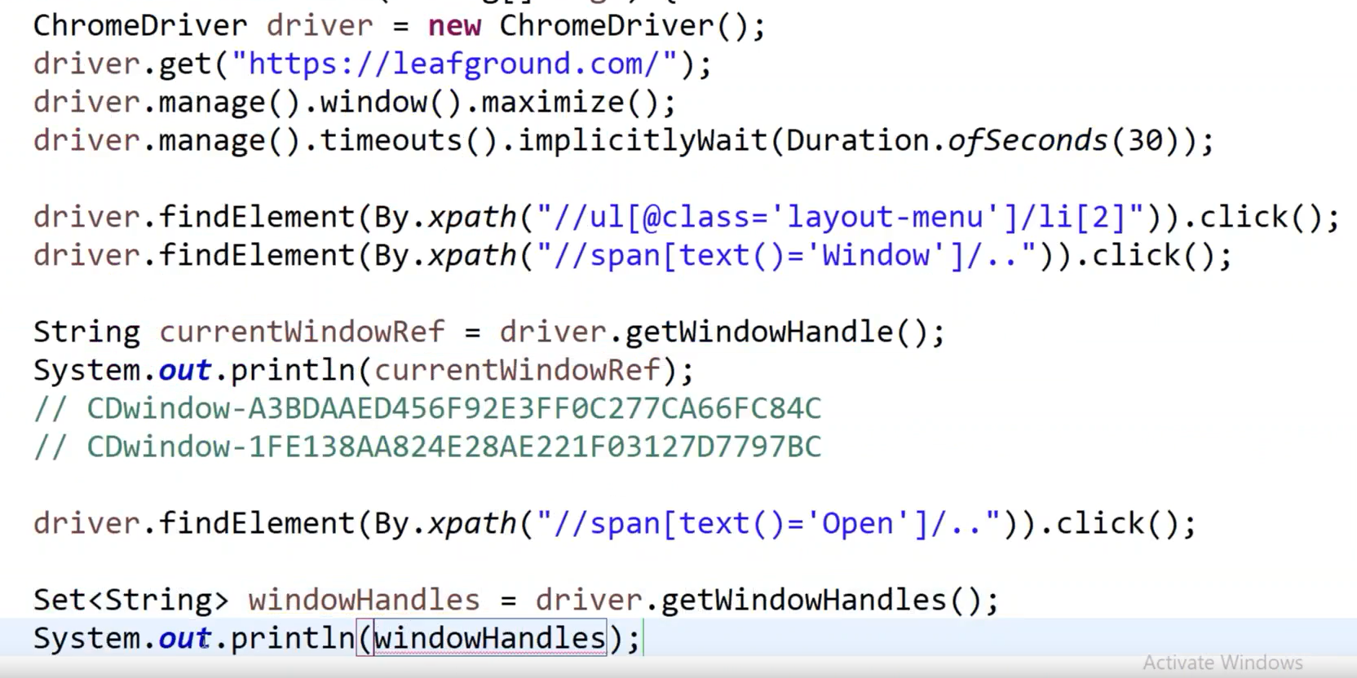

Out put: 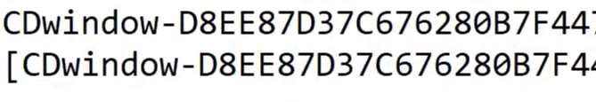

In selenium they have written an unique code